**PERSONAL FINANCEAL ANALYSIS**

**AND RECOMMENDATION SYSTEM**

AN ASSIGNMENT SUBMITTED

IN PARTIAL – FULFILMENT OF THE REQUIREMENT

**FOR**

**THE AWARD OF THE DEGREE OF**

**MASTER’S IN**

**COMPUTER APPLICATIONS**

**BY**

**MD SHAHIL ANSARI SUMIT SOREN**

**Roll. No. 21MCRMS970062 21MCRMS970137**

**Reg. No MCR21M970062 MCR21M970137**



**DEPARTMENT OF MCA.**

**MARWARI COLLEGE, RANCHI-834001**

**(2021-2023)**

**CERTIFICATE**

This is to certify that the work contained in this dissertation entitled "**STUDY OF PERSONAL FINANCIAL ANALYSIS AND RECOMMENDATION SYSTEM”** submitted by MD SHAHIL ANSARI (Roll No. 21MCRMS970062) and SUMIT SOREN (Roll No. 21MCRMS970173) for the award of the degree of Master in Computer Science (MCA), Marwari College Ranchi, is a record of bonafide PROJECT works carried out by him under my direct supervision and guidance.

I considered that the dissertation has reached the standards and fulfilling the requirements of the rules and regulations relating to the nature of the degree. The contents embodied in the dissertation have not been submitted for the award of any other degree or diploma in this or any other university.

Signature of the Project Guide Signature of the Head of the Department

Signature of the examiner

**DECLARATION**

I hereby declare that this work is solely done by me under the supervision of **Dr. DIPTI PRASAD (ASSISTANT PROFESSOR)**, Post Graduate Department of Computer Application.

I certify that the work contained in the project documentation is original and has been done by myself under the supervision of my supervisor. The work has not been submitted to any other Institute for any degree or diploma. I have conformed to the norms and guidelines given in the Ethical Code of Conduct of the Institute. Whenever I have quoted written materials from other sources and due credit is given to the sources by citing them.

DATE: 20/07/2023

MD SHAHIL ANSARI

Roll No-21MCRMS970062

PG DEPARTMENT (MCA)

MARWARI COLLEGE

SUMIT SOREN

Roll No. 21MCRMS970173

PG DEPARTMENT (MCA)

MARWARI COLLEGE

PLACE: RANCHI

**AKNOWLEDGEMENT**

This project is by far the most significant accomplishment in my life and it would have been impossible without people who supported me and believed in my caliber.

I would like to express my gratitude and sincere thanks to my honorable Head of the department Dr. Dipti Prasad, Post-graduation department MCA my guide and my mentor, for giving me an opportunity to work under his guidance and for encouraging me at each step during the duration of the project with his valuable inputs and guidance I would also like to thank my parents and my friends for their support and belief in me.

I would especially like to thank for Coursera, Director Prof for providing learning and working place and all the required material for the dissertation work.

I would like to thanks those who have given support in project creation. I am genuinely appreciative of all my teachers for their suggestions and moral support during my work. Last, but not the least, I would like to thank the Almighty GOD and my parents, whose dedicated and untiring efforts towards me has brought me at this stage of my life.

SUMIT SOREN

MD SHAHIL ANSARI





**CONTENTS**

**ITEMS PAGE NO**.

1. ABSTRACT 1

2. INTRODUCTION 2-7

3. Vision, Mission & Objective

* Vision
* Mission
* Objective

4. SWOT Analysis 8-18

5. Chronology of Achievements 19-29

A. Create blueprint 19

D. Backend & Model development 21

E. Frontend Development 22-24

1. Media Preparation 22

F. Dashboard

6. RESULTS 30-34

7. DISCUSSION 35-38

8. Its relevance & implication in company

9. FINDINGS

10. CONCLUSION 39

11. FURTHER ENHANCEMENT (Suggestion)

12. BIBLIOGRAPHY

13. REFERENCE WEBSITE 60-63

**LIST OF PHOTOGRAPH**

* Codes
* MySQL server workbench
* Tableau Dashboard
* Homepage of the website
* Registration page
* Login page
* Add expense/income page

**LIST OF GRAPH**

**ITEM PAGE NO**.

* Financial dashboard of all graph
* Number representation of all and net income/expense
* Bar graph of Expense by Component with line graph
* Bar graph of Savings by Component with line graph
* Detail of Statement in excel form
* Line Graph of savings and expense in percentage

**LIST OF TABLES**

**TABLE PAGE NO**

TABLE 1: Store the client all personal data

TABLE 2: Different Income and expense daily

TABLE 3: Extra data store such as goal, budget.

1. **ABSTRACT**

The project "Personal Financial Analysis and Recommendation System" is aims to develop a comprehensive software solution to assist individuals in managing their personal finances effectively. The system will analyze users' financial data, provide insights into their financial health, and offer personalized recommendations to achieve their financial goals.

The purpose of this personal finance analysis project is to provide an in-depth understanding of the financial situation of an individual or household. The project will involve collecting and analyzing financial data, including income, expenses, debts, and assets, to identify patterns and trends in their financial behavior.

This project aims to help individuals achieve financial stability and success. By providing personalized financial insights and recommendations, the system empowers users to make informed choices and take proactive steps towards financial security and wealth accumulation.

**Keywords**: Recommender Systems, Case-based Reasoning, Personalization, Analysis, Visualization

**Introduction with Company Profile:**

The Personal Financial Analysis and Recommendation project is a strategic initiative undertaken by Coursera, a leading online learning platform, as part of its Professional Data Analytics course. Coursera is a renowned edtech company that offers a wide range of high-quality online courses and certifications across various disciplines, including data analytics, finance, technology, and more. With millions of learners worldwide, Coursera has established itself as a trusted provider of educational resources that empower individuals to acquire in-demand skills and advance their careers.

**Company Profile:**

Coursera was founded in 2012 by Stanford University professors Andrew Ng and Daphne Koller, with the mission of providing universal access to world-class education. The platform collaborates with top universities and industry experts to offer online courses that cover a diverse range of topics, catering to learners of all backgrounds and aspirations. Coursera's cutting-edge technology and innovative pedagogy enable learners to acquire valuable skills through interactive, self-paced learning experiences.

Coursera's Professional Data Analytics course is a comprehensive program designed to equip learners with the skills and knowledge needed to excel in the field of data analytics. The course covers a wide range of topics, including data manipulation, visualization, statistical analysis, machine learning, and more. Learners in this course gain hands-on experience by working on real-world data projects and assignments, building their proficiency in data analysis and interpretation.

The Personal Financial Analysis and Recommendation project is an implementation part of the Professional Data Analytics course offered by Coursera. The project aims to leverage data analytics techniques to develop a powerful platform that enables learners to analyze their personal finances effectively. Learners will gain insights into their financial health, receive personalized recommendations for financial planning, and enhance their financial literacy through educational resources.

The project aligns perfectly with Coursera's mission of providing accessible and high-quality education to learners worldwide. By empowering individuals with personalized financial analysis tools and recommendations, Coursera aims to equip learners with essential financial skills that can positively impact their lives. Learners in the Professional Data Analytics course have the opportunity to apply their data analytics skills to create innovative solutions that address real-world challenges, making this project an essential part of their learning journey.

In collaboration with industry experts and mentors, Coursera envisions the Personal Financial Analysis and Recommendation project as a transformative learning experience, enhancing learners' ability to make informed financial decisions and achieve long-term financial well-being. By bridging the gap between data analytics and personal finance, this project exemplifies Coursera's commitment to empowering learners to thrive in an increasingly data-driven world.

1. **INTRODUCTION**

Personal finance analysis is a crucial aspect of financial planning and management. It involves evaluating an individual's financial situation, including income, expenses, debts, and assets, to determine their current financial position and identify opportunities for improvement.

The purpose of this personal finance analysis project is to provide an in-depth understanding of the financial situation of an individual or household. The project will involve collecting and analyzing financial data, including income, expenses, debts, and assets, to identify patterns and trends in their financial behavior.

The analysis will be conducted using various financial metrics, including net worth, debt-to-income ratio, savings rate, and budgeting analysis. The project will also involve identifying areas of financial strength and weakness, such as excessive spending, inadequate savings, or high levels of debt.

The project will provide insights into the individual's financial situation, including their ability to meet financial goals, such as retirement, education, or debt repayment. The analysis will also provide recommendations for improving their financial situation, such as reducing expenses, increasing income, or consolidating debt.

Overall, the personal finance analysis project will provide valuable insights into an individual's financial situation and help them make informed decisions about their financial future

**Problem definition**

Personal finance analysis projects aim to solve various financial problems that individuals or households face. These problems can be broadly classified into two categories: financial health problems and financial goal problems.

Financial health problems refer to the current financial situation of an individual or household, which includes income, expenses, debts, and assets. The problems in this category can range from high levels of debt, low savings rate, lack of financial stability, and poor credit score. The main aim of personal finance analysis projects in this category is to identify the root cause of these problems and provide actionable recommendations to improve the financial health of the individual or household.

Financial goal problems refer to achieving specific financial goals, such as saving for retirement, buying a house, or paying off debt. These problems require a detailed analysis of the individual's financial situation to determine the feasibility of achieving their financial goals. Personal finance analysis projects in this category aim to identify the resources required to achieve the financial goal and provide recommendations on how to allocate funds efficiently to meet the goal.

Some other common problems that personal finance analysis projects aim to solve include inefficient spending, lack of financial discipline, inadequate financial planning, and high levels of financial stress.

The main objective of personal finance analysis projects is to help individuals or households achieve financial well-being by identifying and solving their financial problems.

# **Vision**

# The vision of the Project is to empower individuals to achieve financial security, make informed financial decisions, and effectively manage their personal finances. The project aims to provide users with a comprehensive platform that offers personalized financial analysis, insights, and actionable recommendations tailored to their unique financial goals and circumstances.

# **Key Points:**

# **Financial Health Assessment:** The project will conduct a thorough analysis of the user's financial health by aggregating and analyzing their income, expenses, debts, investments, and assets.

# **Goal-Based Planning:** Users will be able to set specific financial goals, such as retirement planning, saving for education, buying a house, or debt repayment. The platform will create personalized financial plans to achieve these goals.

# **Budgeting and Expense Tracking:** The project will enable users to create budgets and track their expenses to gain better control over their spending and identify areas for improvement.

# **Investment Analysis:** Users will receive investment analysis reports to evaluate their existing investments' performance and risk level, and get recommendations for optimizing their investment portfolio.

# **Risk Management:** The platform will provide insights into potential financial risks and offer strategies to protect against unforeseen events, such as emergencies or health issues.

# **Tax Planning:** Users will receive guidance on tax planning strategies to minimize tax liabilities and maximize tax benefits.

# **Education and Financial Literacy:** The project will include educational resources to enhance users' financial literacy and improve their understanding of personal finance concepts.

# **Real-Time Updates:** Users will have access to real-time financial data and market trends, helping them make informed decisions based on the latest information.

# **Data Security and Privacy:** Ensuring the utmost security and privacy of users' financial data will be a priority, implementing robust data protection measures.

# **Personalized Recommendations:** Recommendations will be personalized to each user's financial situation, risk tolerance, and long-term objectives, offering tailored solutions.

# Overall, the Personal Financial Analysis and Recommendation Project aims to serve as a reliable and user-friendly financial planning platform, assisting individuals in achieving financial stability, meeting their goals, and building a prosperous financial future. The project aspires to be the go-to resource for users seeking comprehensive financial guidance and strategic financial management.

# **Mission**

# The mission of the Project is to leverage advanced technologies and data analytics to deliver a user-centric, comprehensive, and secure platform for individuals to gain control over their finances and make well-informed financial decisions. Our mission encompasses the following key objectives:

# 1. Empower Financial Literacy: We aim to enhance financial literacy among users by providing accessible and easy-to-understand educational resources on various aspects of personal finance. Our project seeks to empower individuals with the knowledge needed to make informed financial choices.

# 2. Personalized Financial Insights: We strive to offer personalized financial analysis and insights to each user based on their unique financial circumstances, goals, and risk preferences. By tailoring recommendations, we help users develop effective financial plans aligned with their aspirations.

# 3. Holistic Financial Planning: Our project aims to take a holistic approach to financial planning, considering factors such as income, expenses, investments, debts, tax implications, and risk management. We provide comprehensive financial solutions that address all aspects of users' financial lives.

# 4. Seamless User Experience: We are committed to delivering a seamless and user-friendly experience, ensuring that our platform is accessible across various devices and offers intuitive navigation. Users can easily access their financial data, reports, and recommendations with minimal effort.

# 5. Data Security and Privacy: We prioritize the security and privacy of users' financial information. Our project adheres to industry-leading data security standards, implementing robust encryption and authentication measures to safeguard user data.

# 6. Real-Time Data and Insights: We aim to provide users with up-to-date financial data, market trends, and economic indicators, enabling them to make timely and well-informed financial decisions.

# 7. Goal Achievement and Financial Independence: Our mission is to help users achieve their financial goals, whether it be saving for retirement, buying a home, paying off debts, or funding education. We aspire to empower users to attain financial independence and peace of mind.

# 8. Continuous Improvement and Innovation: We are committed to continuous improvement and innovation in our project. We actively seek feedback from users to enhance our platform's features and ensure it remains relevant to their evolving financial needs.

# 9. Accessibility and Inclusivity: We strive to make our project accessible to a diverse user base, including individuals from various socioeconomic backgrounds. We aim to foster financial inclusion by offering valuable financial services to all.

# 10. Long-Term Financial Well-Being: Ultimately, our mission is to contribute to the long-term financial well-being of our users. Through personalized recommendations and financial insights, we aspire to empower individuals to build a secure and prosperous financial future.

# By fulfilling our mission, the Personal Financial Analysis and Recommendation Project for MCA seeks to be a trusted and valuable resource for individuals seeking comprehensive financial guidance, leading to improved financial health and resilience.

# **Objective**

The objective of a personal finance analysis project is to provide an in-depth understanding of an individual or household's financial situation. The analysis aims to identify their financial strengths and weaknesses, determine their financial goals, and recommend actionable steps to improve their financial well-being.

The specific objectives of a personal finance analysis project can vary depending on the individual's needs and goals. However, some common objectives include:

* **Understanding the current financial situation:** The project aims to analyze the individual's income, expenses, debts, and assets to determine their current financial position.
* **Identifying areas of financial weakness**: The project aims to identify areas where the individual or household is overspending, has high levels of debt, or lacks adequate savings.
* **Assessing financial risks:** The project aims to evaluate the individual's exposure to financial risks such as inflation, job loss, or market volatility.
* **Developing a financial plan**: The project aims to develop a comprehensive financial plan that aligns with the individual's goals and objectives.
* **Providing actionable recommendations**: The project aims to provide recommendations on how to improve the individual's financial situation, such as reducing expenses, increasing income, or consolidating debt.
* **Monitoring progress:** The project aims to track the individual's progress towards achieving their financial goals and make necessary adjustments to their financial plan.

It help individuals or households achieve financial well-being by providing a comprehensive analysis of their financial situation and developing actionable recommendations to improve their financial health.

**SWOT Analysis**

SWOT analysis is a strategic planning technique used to evaluate the Strengths, Weaknesses, Opportunities, and Threats of a project or business venture. Here's how you can write the SWOT analysis for the Personal Financial Analysis and Recommendation Project:

**1. Strengths:**

* Advanced Technology: The project utilizes cutting-edge technologies and data analytics to provide accurate and personalized financial analysis and recommendations.
* Comprehensive Platform: The platform offers a wide range of financial services, including budgeting, investment analysis, goal-based planning, and risk management, all in one place.
* User-Centric Approach: The project is designed with a focus on the needs and preferences of the users, delivering a seamless and user-friendly experience.
* Financial Literacy Resources: The inclusion of educational resources enhances users' financial literacy, empowering them to make informed decisions.
* Data Security: Robust data security measures ensure the confidentiality and integrity of users' financial information.

**2. Weaknesses:**

* Initial User Onboarding: Acquiring a substantial user base may require effective marketing and outreach efforts to raise awareness of the platform's benefits.
* Learning Curve: Users may require time to understand and adapt to the features and functionalities of the platform.

**3. Opportunities:**

* Growing Demand for Financial Planning: The increasing awareness of the importance of financial planning presents an opportunity for the project to cater to a growing market.
* Partnerships with Financial Institutions: Collaborating with banks or financial institutions could expand the project's reach and provide additional resources to users.

**4. Threats:**

* Market Competition: The project may face competition from existing financial planning tools and services, requiring differentiation strategies to stand out.
* Regulatory Changes: Evolving financial regulations and compliance requirements may impact the project's operations and data handling.

Remember that a SWOT analysis is an internal and external assessment of the project's current state and potential future. It can help in identifying areas of improvement and formulating strategies to capitalize on opportunities and mitigate threats.

**4. Chronology of Achievements**

**A. Create blueprint**

**B. Backend & Model development**

**C. Frontend Development**

* **Media Preparation**

**D. Dashboard**

The chronology of achievements for the project can be summarized as follows:

**A. Create Blueprint:**

In this phase, the project team works on designing the overall architecture and planning the features and functionalities of the Personal Financial Analysis and Recommendation platform. This blueprint acts as a roadmap for the project's development.

**B. Backend & Model Development:**

The backend (**Django framework**) and model development is a critical phase where the project team focuses on building the core functionality of the platform. This includes setting up the server-side infrastructure, database management (**MySQL server**), and developing the algorithms and models required for financial analysis and recommendations.

**C. Frontend Development:**

Frontend development (**html, css and bootstrap**) involves creating the user interface and user experience for the platform. The project team designs and implements the visual elements, layout, and interactive features to ensure a seamless and engaging user experience.

* **Media Preparation:**

As part of frontend development, the team prepares the media elements such as **images, icons**, and other graphical assets that will be used to enhance the visual appeal of the platform.

**D. Dashboard:**

The dashboard (**Using tableau**) is a central component of the Personal Financial Analysis and Recommendation platform. It is the user-facing interface where users can view their financial data, analysis reports, and receive personalized recommendations.

The achievement chronology represents the sequential order in which the major milestones are accomplished during the project development process. However, it's important to note that software development is an iterative and continuous process, and these achievements may overlap or evolve over time based on the project's scope and requirements. Additionally, after the initial development, there would be further phases for testing, deployment, and maintenance to ensure the platform's smooth functioning and continuous improvement based on user feedback.

**5. RESULTS**

The Results highlights the significant milestones and outcomes achieved at various stages of the project development. It provides a summary of the progress made and the results obtained in each phase. Here is an example of what can be written about the Chronology of Achievements Results for the Personal Financial Analysis and Recommendation Project:

**Create Blueprint:**

**Result:** The project team successfully created a comprehensive blueprint outlining the architecture, features, and functionalities of the Personal Financial Analysis and Recommendation platform. This blueprint served as a roadmap for the entire project development process.

**Backend & Model Development**:

**Result:** The backend infrastructure and database management were successfully set up. The team developed sophisticated algorithms and financial models for accurate data analysis and personalized recommendations. Key achievements include seamless integration with external financial data sources and robust data handling capabilities.

**Frontend Development:**

**Result:** The frontend development resulted in an intuitive and visually appealing user interface for the platform. The team implemented interactive features, responsive design, and a user-centric layout, enhancing the overall user experience.

**Media Preparation:**

**Result:** The media preparation phase delivered a collection of high-quality images, icons, and graphical assets that were seamlessly integrated into the platform's frontend. These visual elements added a professional and polished look to the user interface.

**Dashboard:**

**Result:** The dashboard, a core component of the platform, was successfully developed and delivered. Users could access their financial data, analysis reports, and personalized recommendations through an easy-to-navigate and visually engaging dashboard. Key achievements include real-time data updates and dynamic visualization of financial trends.

**Financial Analysis and Insights:**

**Result:** The financial analysis and recommendation engine provided users with comprehensive insights into their financial health. Users received personalized reports on budgeting, investment performance, risk management, and goal-based planning, empowering them to make informed financial decisions.

**User Feedback and Continuous Improvement:**

**Result:** User feedback was actively collected and analyzed throughout the project's development. Continuous improvements were made based on user suggestions, leading to enhancements in the platform's usability and functionality.

The Chronology of Achievements Results demonstrates the successful implementation of the project's core features and the positive impact on users' financial planning and decision-making. It reflects the dedication of the project team to deliver a reliable and user-centric platform that meets the diverse financial needs of users.

**6. DISCUSSION**

The Personal Financial Analysis and Recommendation project aimed to empower individuals to achieve financial security, make informed financial decisions, and effectively manage their personal finances. This section provides a detailed discussion of the project's objectives, methodology, achievements, challenges, impact, and future enhancements.

**Features**

* ✅ Modern Themed Design (BS4)
* ✅ MYSQL Database, Django Native ORM
* ✅ Session-Based Authentication, Forms validation
* ✅ Deployment scripts: Localhost

## **Environment**[**​**](https://docs.appseed.us/products/django-dashboards/atlantis-dark#environment)

To use the starter, [Python3](https://www.python.org/) should be installed properly in the workstation. If you are not sure if Python is installed, please open a terminal and type python --version. Here is the full list with dependencies and tools required to build the app:

* [Python3](https://www.python.org/) - the programming language used to code the app
* [GIT](https://git-scm.com/) - used to clone the source code from the GitHub repository
* Basic development tools (**vscode, MySQL workbench, tableau & python** development libraries etc.) used by Python to compile the app dependencies in your environment.

**Manual Build**

**Download the code**

# Get the code

git clone <https://github.com/shahil04/personal_finance_webapp.git>

cd peraonal_finance_webapp

👉 **Set Up for Unix, MacOS**

**Install modules via VENV**

virtualenv env

source env/bin/activate

pip3 install -r requirements.txt

**Set Up Database**

python manage.py makemigrations

python manage.py migrate

**Start the app**

python manage.py runserver

At this point, the app runs at http://127.0.0.1:8000/.

**👉 Set Up for Windows**

**Install modules via VENV (windows)**

$ virtualenv env

$ .\env\Scripts\activate

$ pip3 install -r requirements.txt

**Set Up Database**

$ python manage.py makemigrations

$ python manage.py migrate

**Start the app**

$ python manage.py runserver

At this point, the app runs at http://127.0.0.1:8000/.

**Manage App Users**

By default, the starter is not provided with users. To access the private pages and the admin section (reserved for **superusers**) follow up the next sections.

👉 **Create Superusers**

To access the admin section, Django requires superuser privilegies. Let's create a new superuser and access the admin section of the project:

$ **python manage.py createsuperuser**

Once the superuser is successfully created, we can access the admin section:

**http://localhost:8000/admin/** (make sure you have a / at the end).

**Main Project files**

**Codebase Structure**[**​**](https://docs.appseed.us/products/django-dashboards/atlantis-dark#codebase-structure)**:** The project is coded using a simple and intuitive structure presented below:





**Requrements.txt** to use libraries in project

asgiref==3.7.2

Django==4.2.3

mysqlclient==2.2.0

sqlparse==0.4.4

typing_extensions==4.7.1

tzdata==2023.3



Figure 1 Manage.py for run the website environment



Figure 2 Setting.py all setup code (app, database, hosting, authentications, templates path)



Figure 3 all app urls links add in project urls.py

**Authentication app files** 

Figure 4 Forms.py to add Registration form



Figure 5 Models.py to create database schema



Figure 6 Views.py to add view of register login and logout



Figure 7 urls.py add url of register, login, logout



Figure 8 admin.py to show data in admin panel



Figure 9 Tree structure of files in project app

**Home App to add all page Codes**



Figure 10 home admin.py to show data in admin panel



Figure 11 home models.py create database schema



Figure 12 home forms.py to add/fill data



Figure 13 home views.py to show the form in website



Figure 14 home urls.py add urls pages

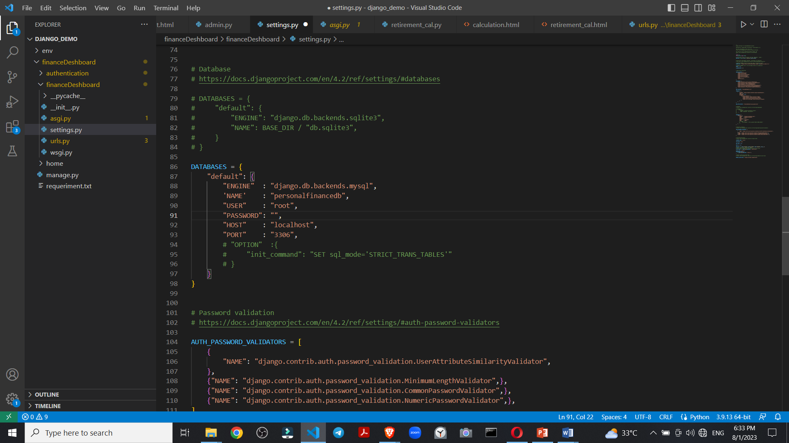

Figure 15 Django main project files

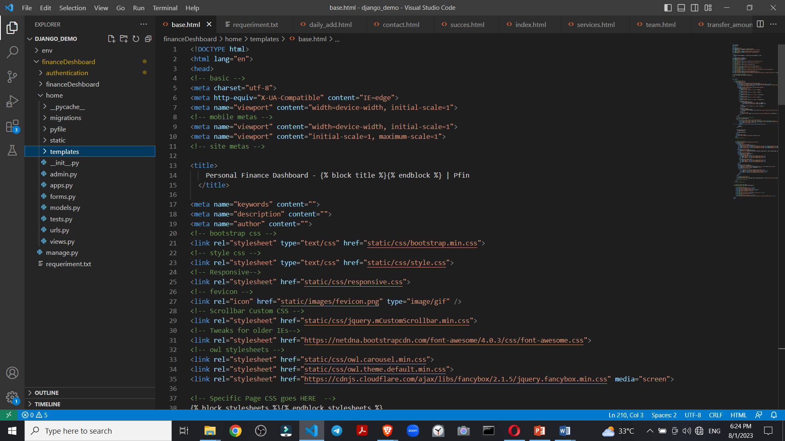

Figure 16 template files

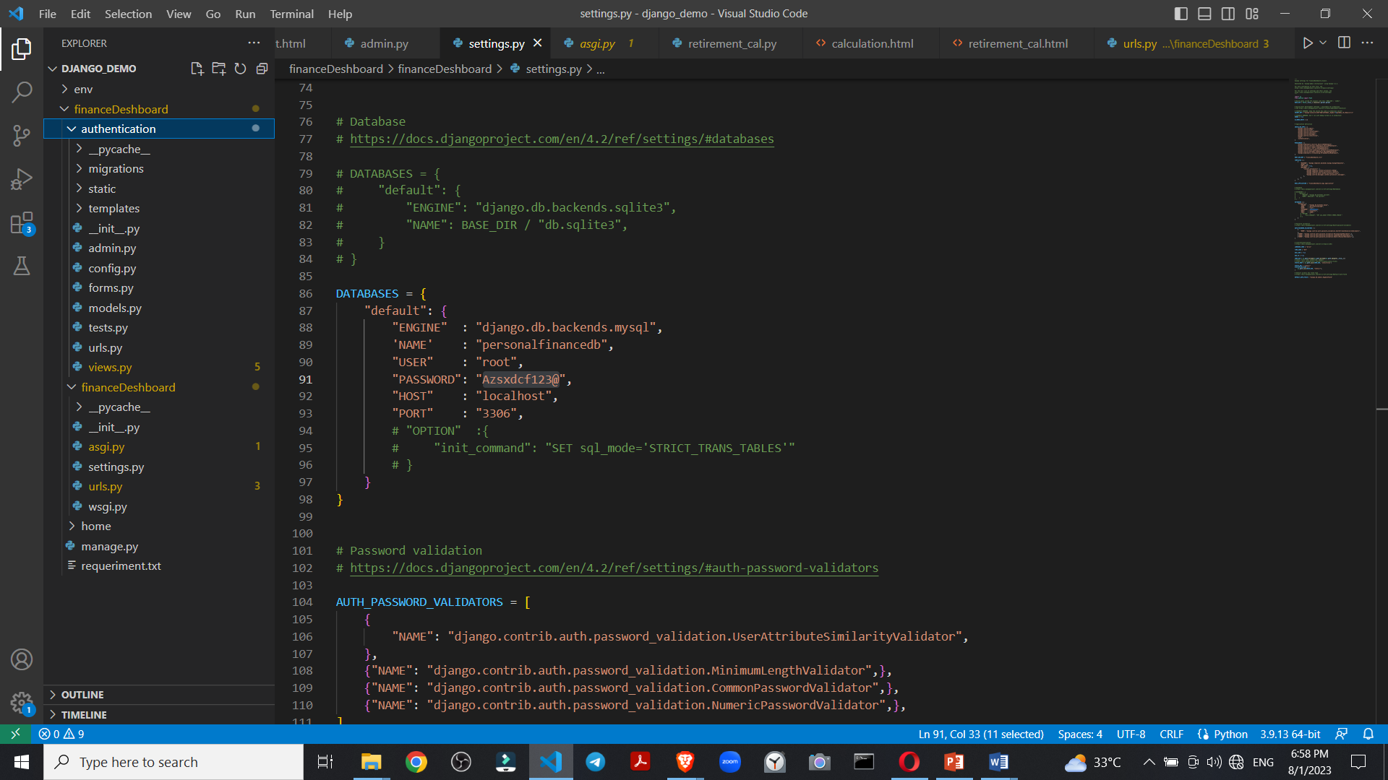

Figure 17 Authentication app files

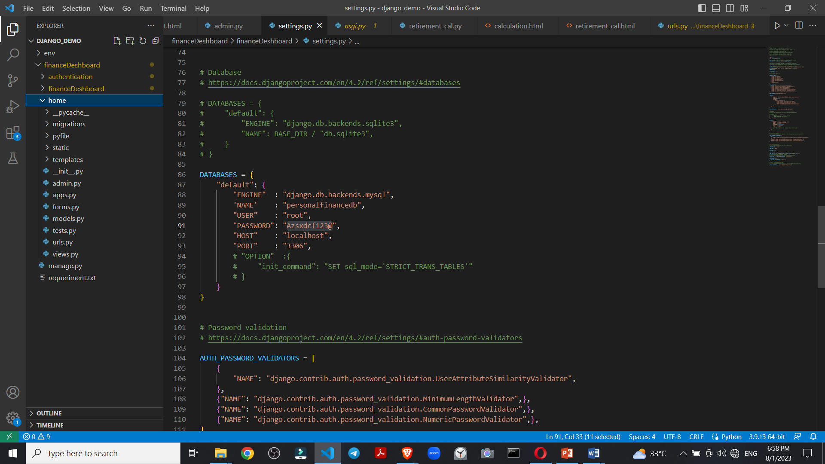

Figure 18 home app files



Figure 19 dataset in excel file

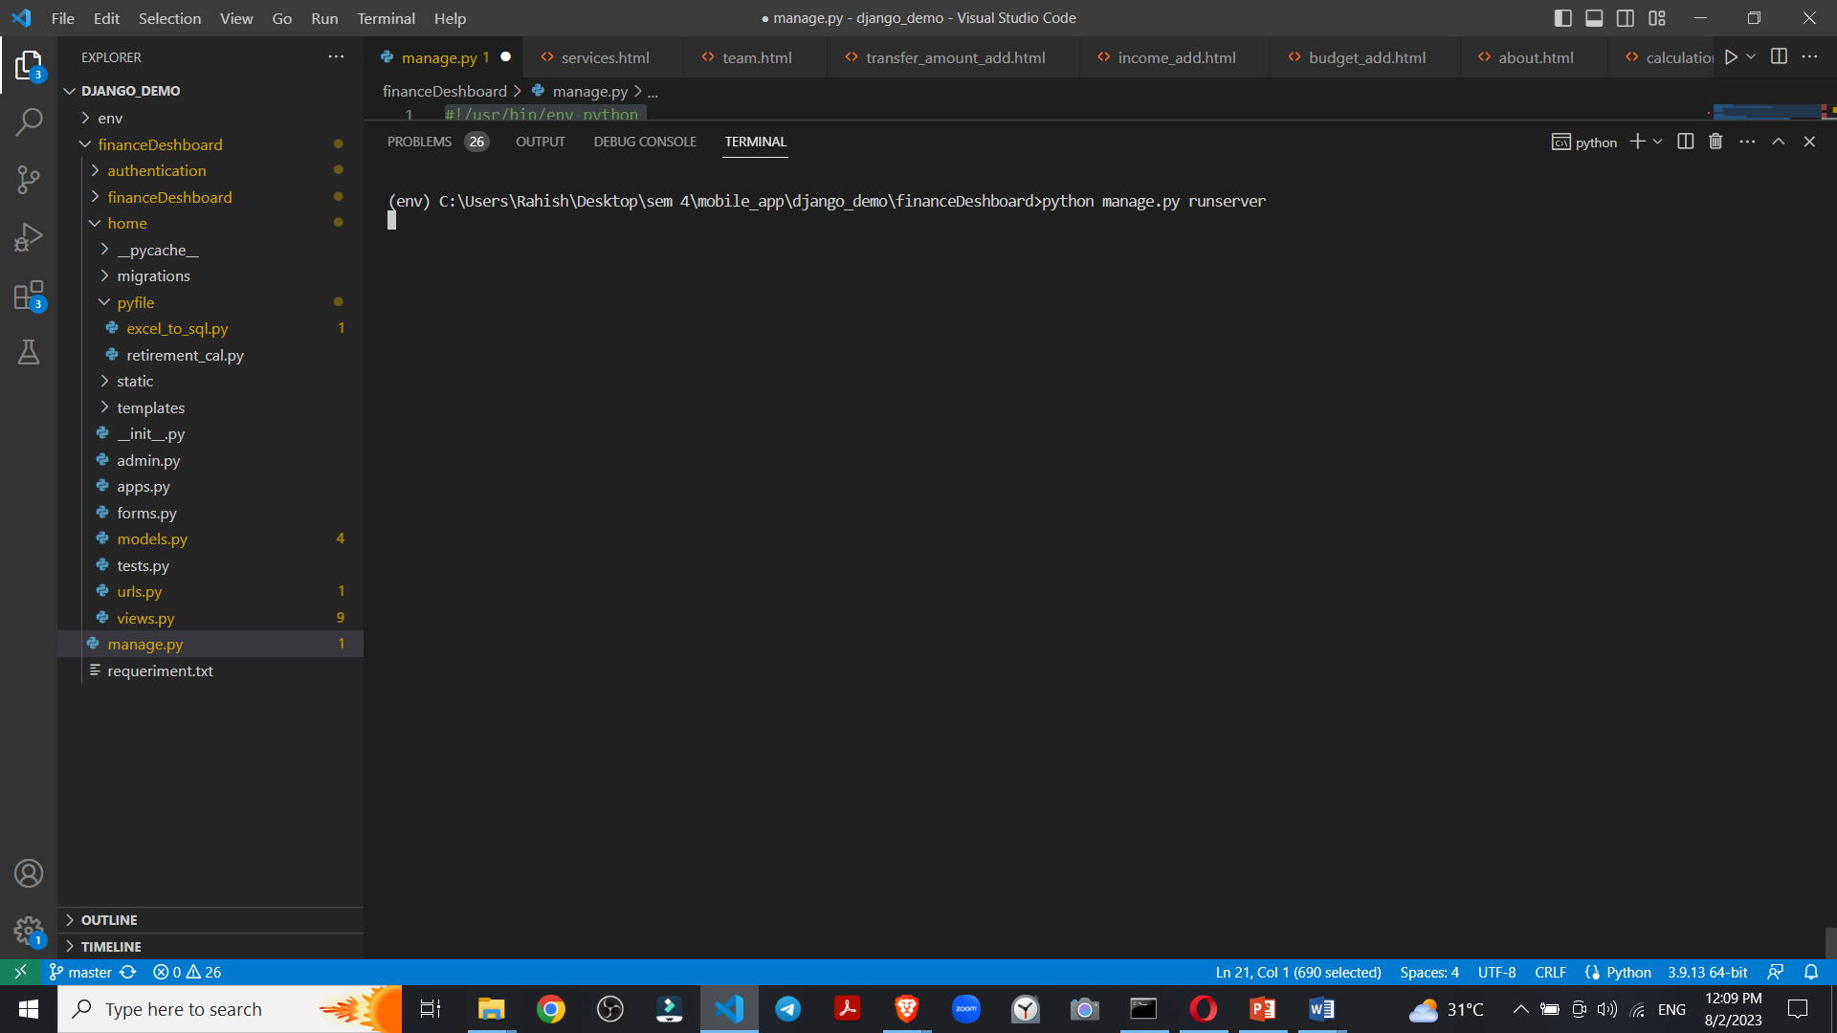

Figure 20 run the server of website

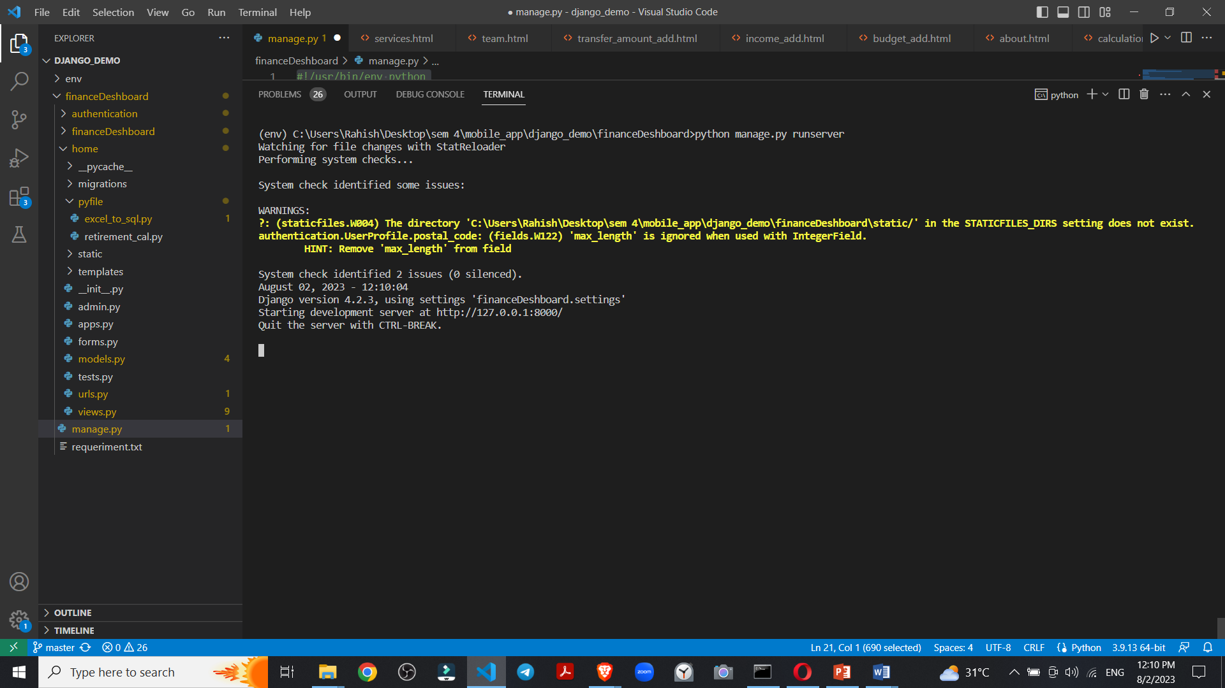

Figure 21 Local host 127.0.0.1:8000/

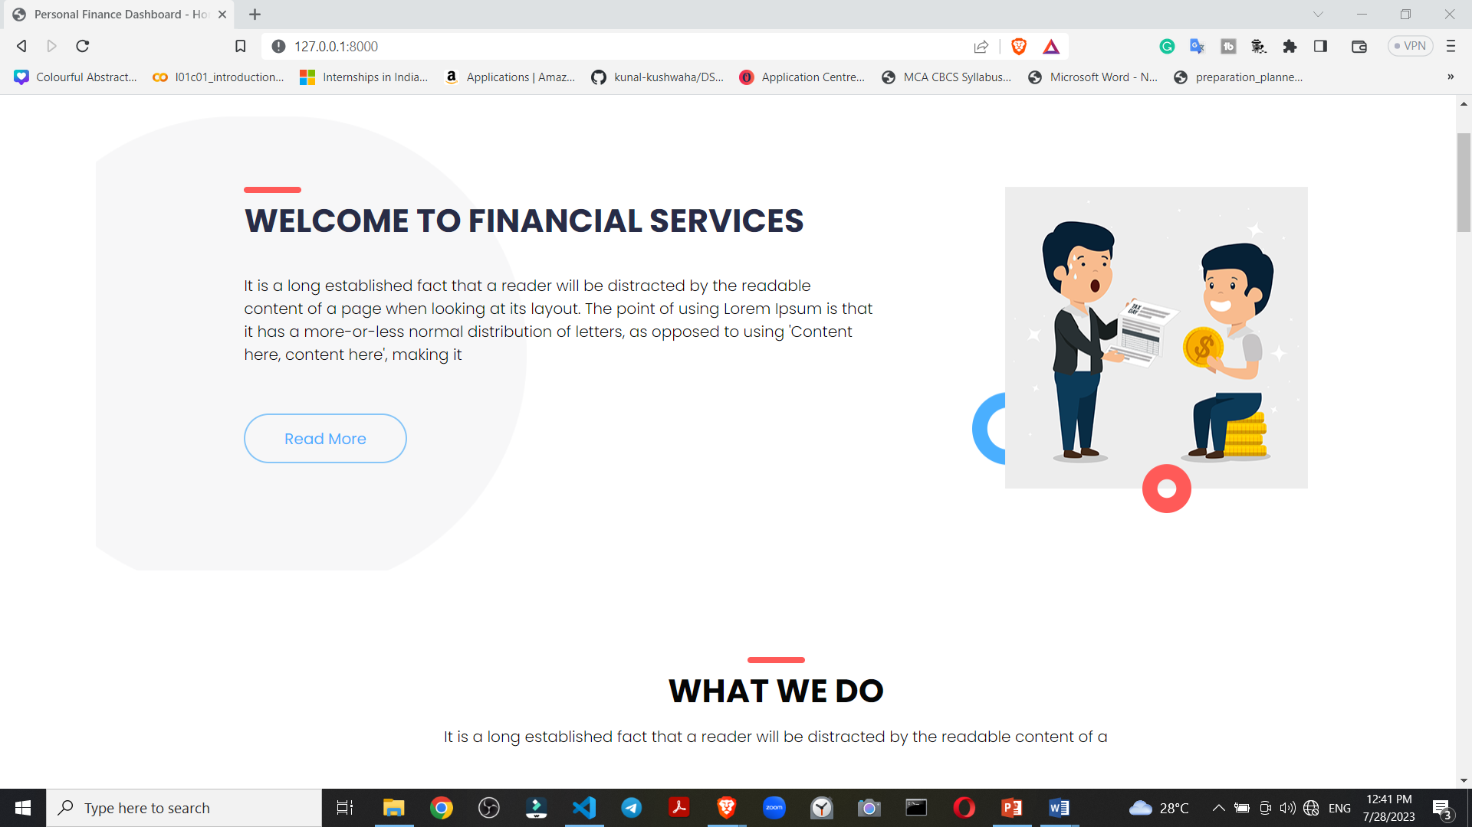

Figure 22 Home page of application

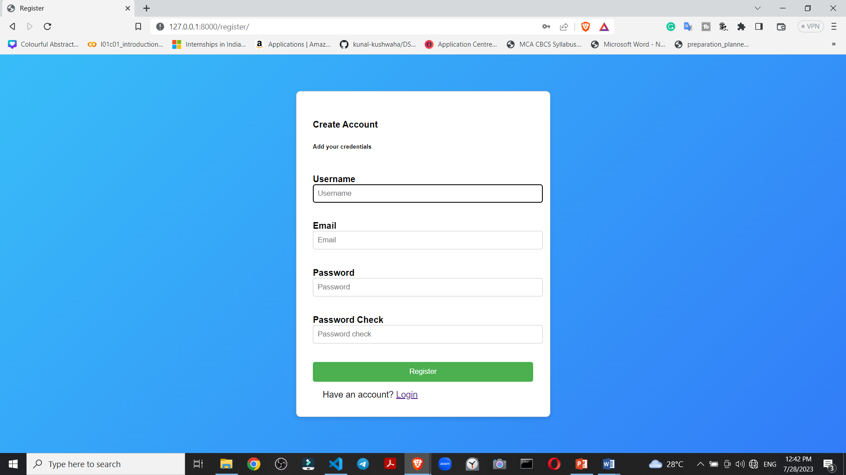

Figure 23 User Registration page

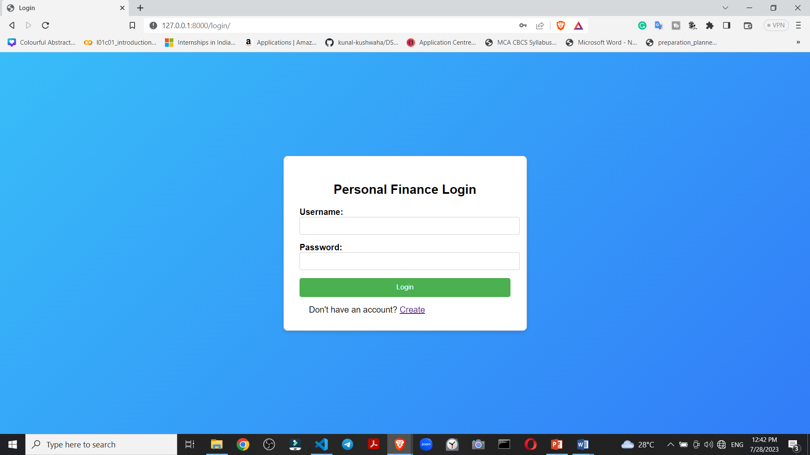

Figure 24 User Login page

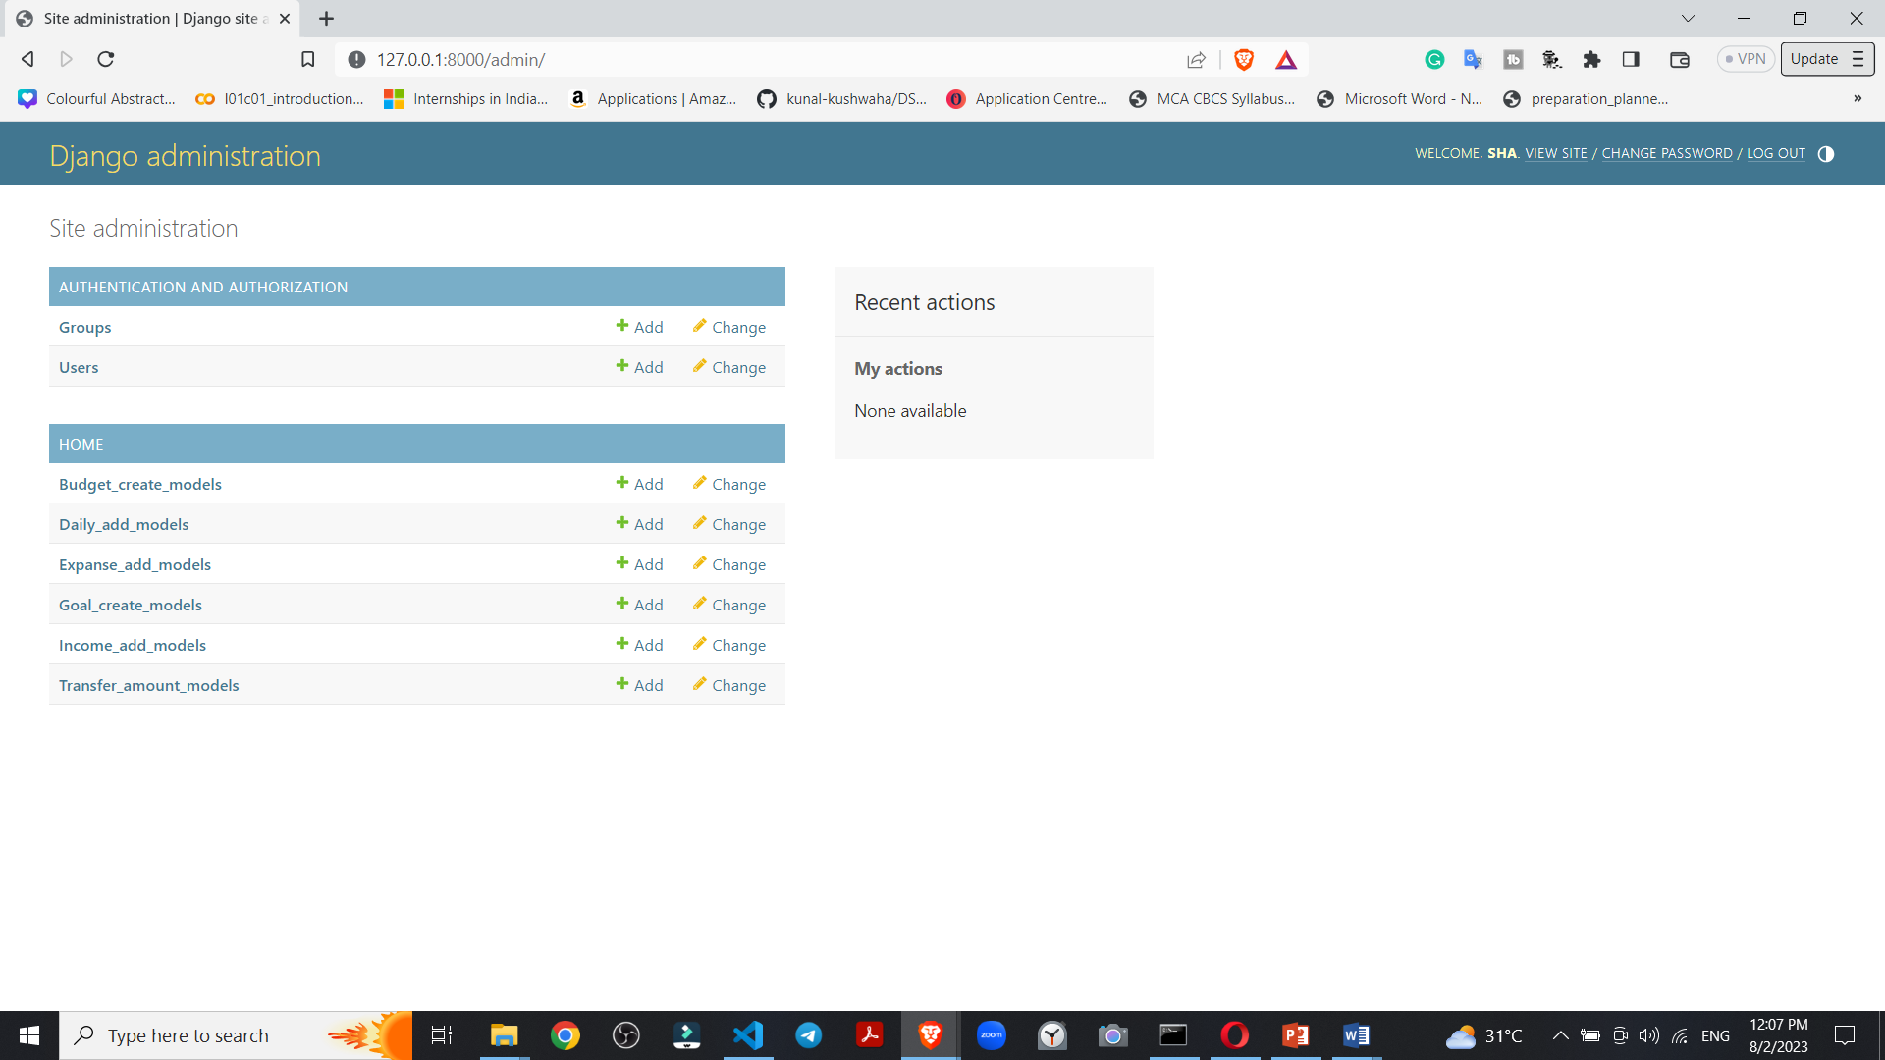

Figure 25 Django administration

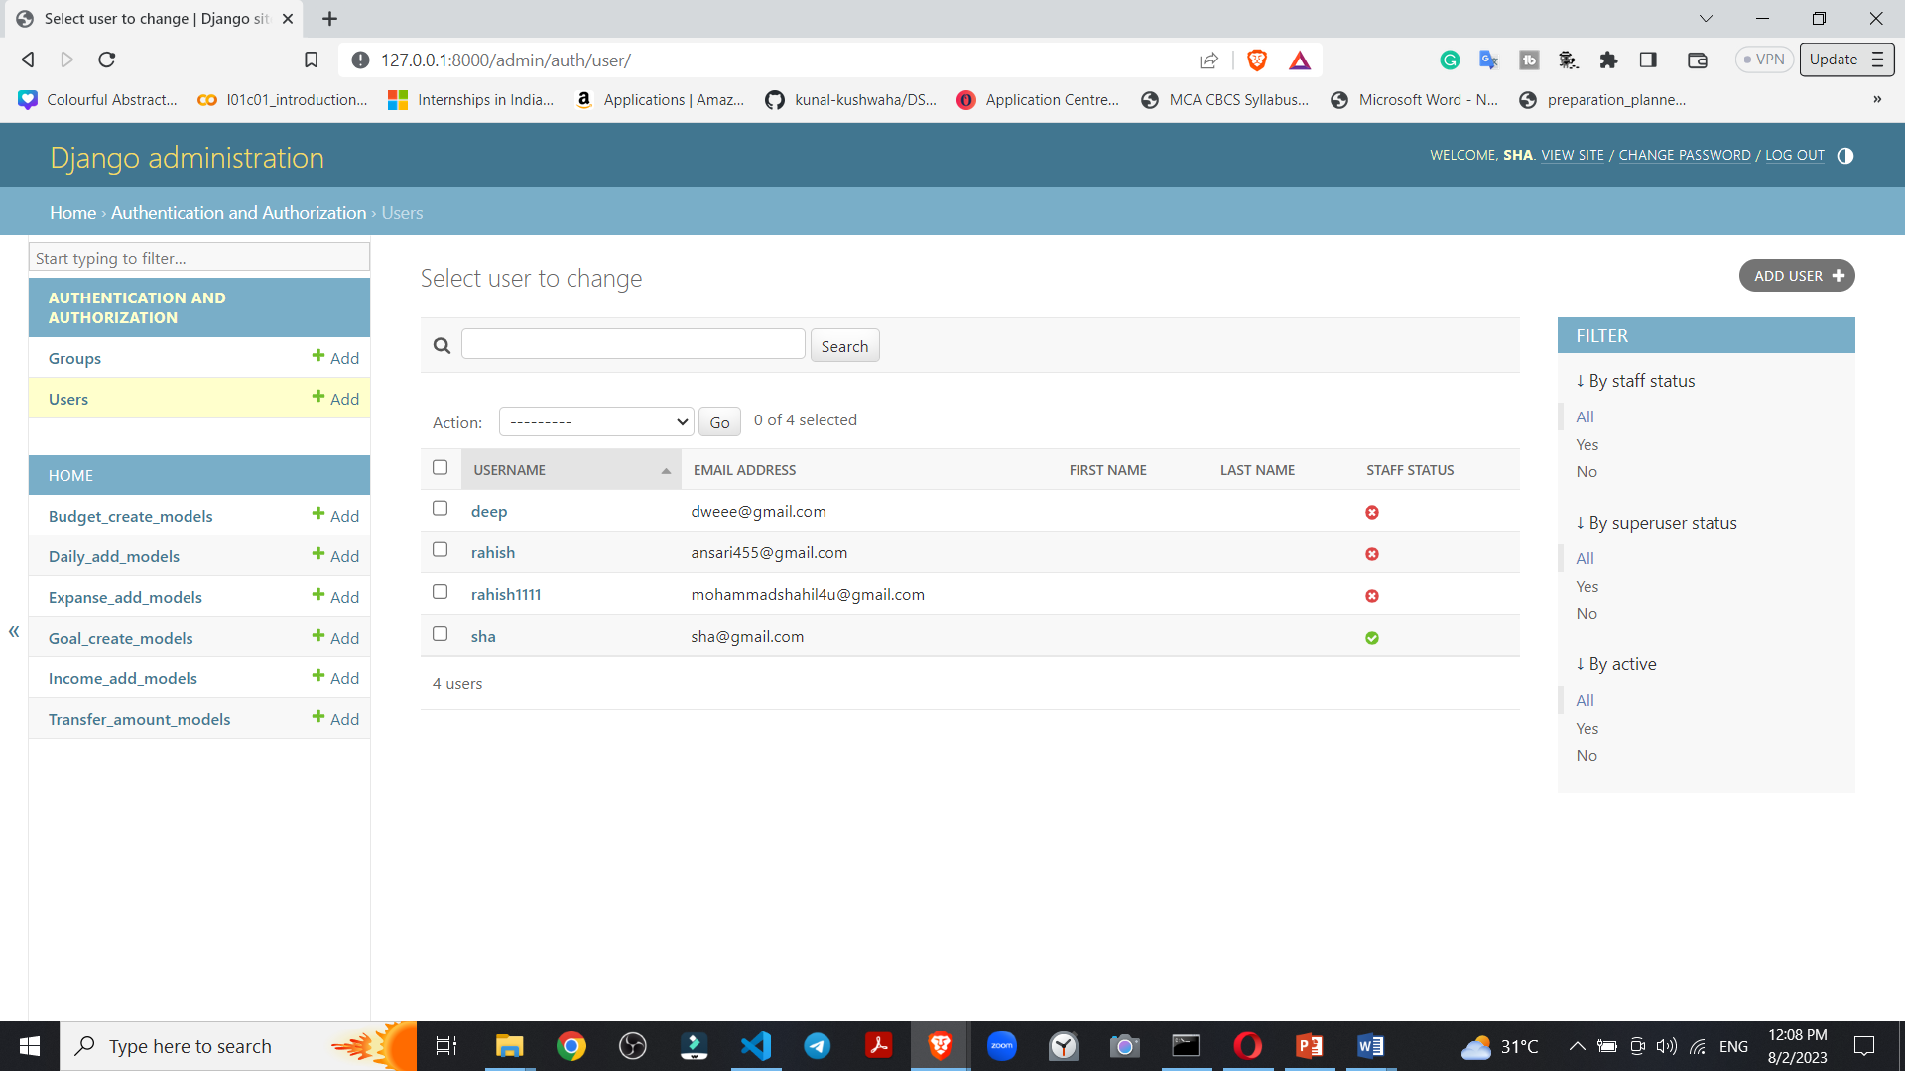

Figure 26 User Details

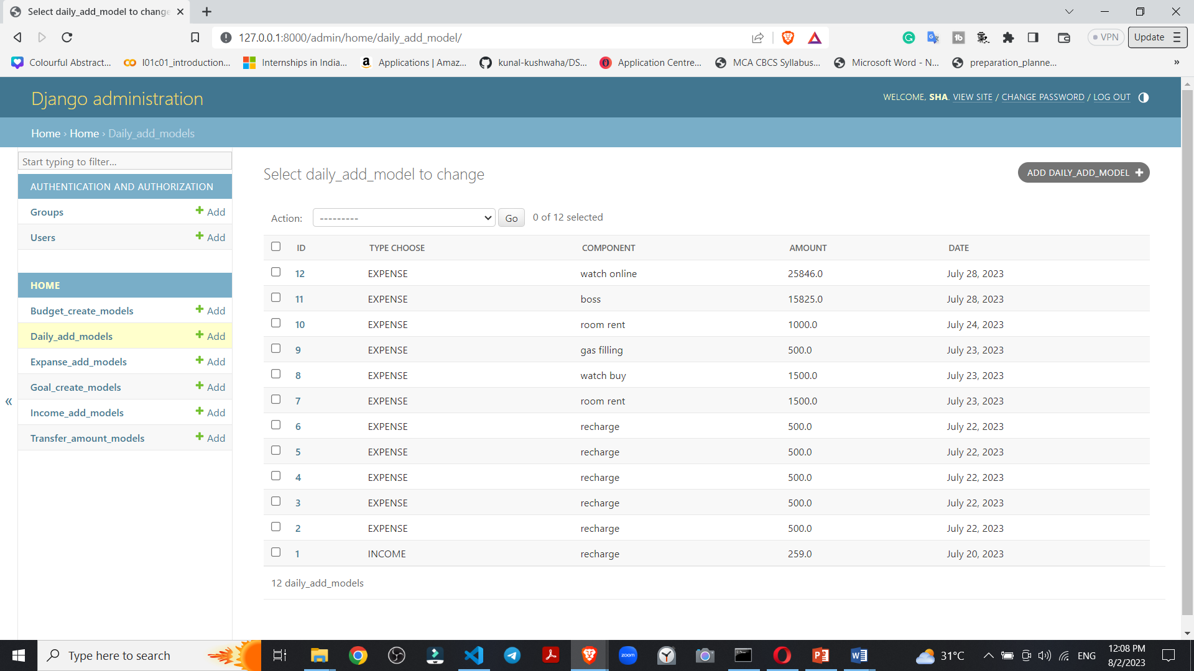

Figure 27 Backed data store in admin panel

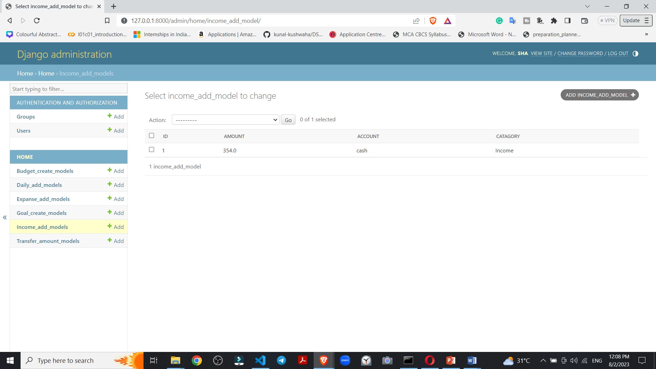

Figure 28 Income data in panel

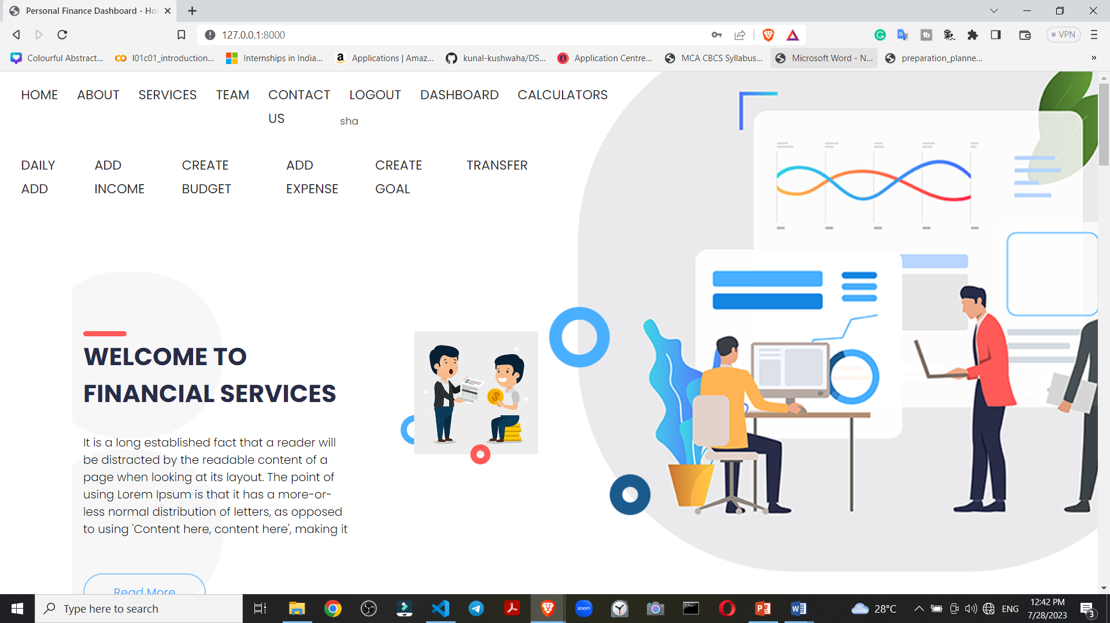

Figure 29 After login page view

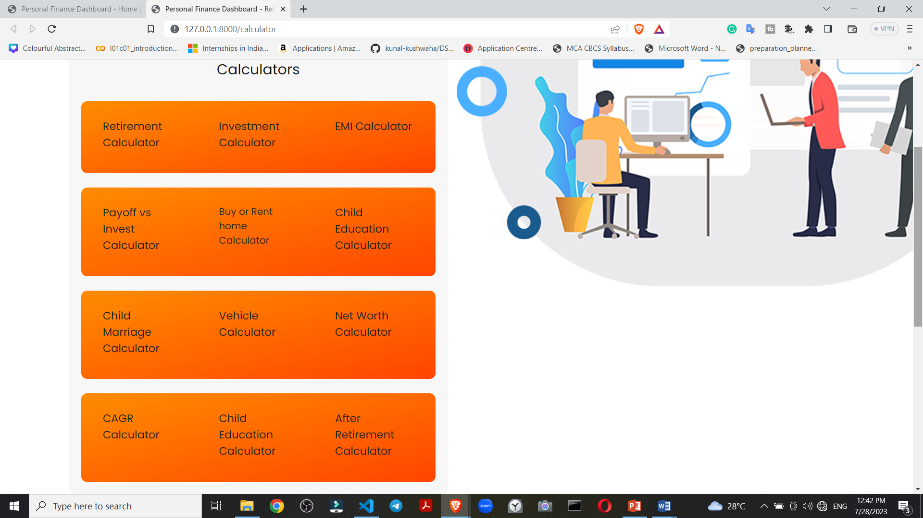

Figure 30 Different calculators for recommendation of planning

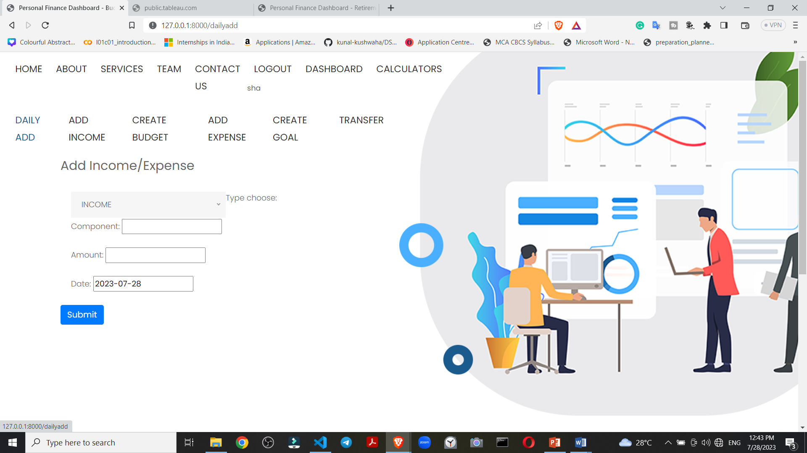

Figure 31 add daily expense

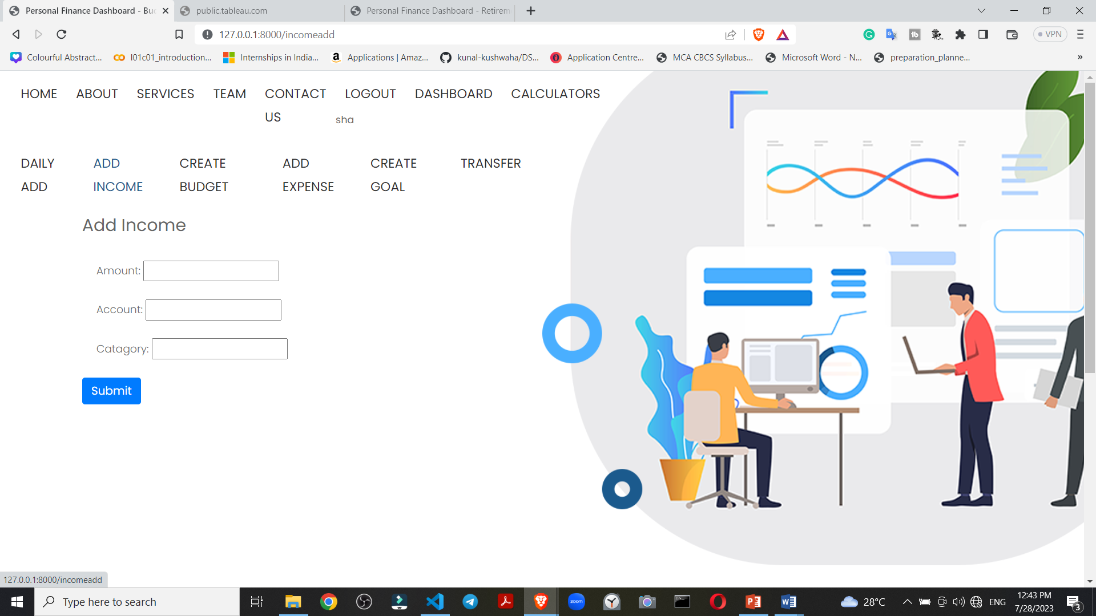

Figure 32 Add Income

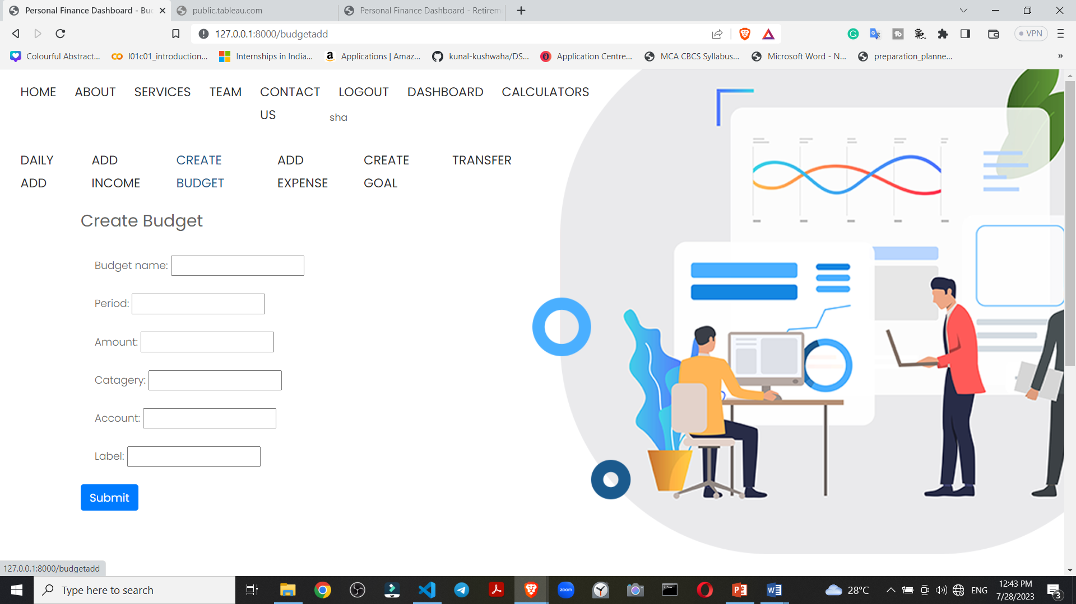

Figure 33 create your budget of expense

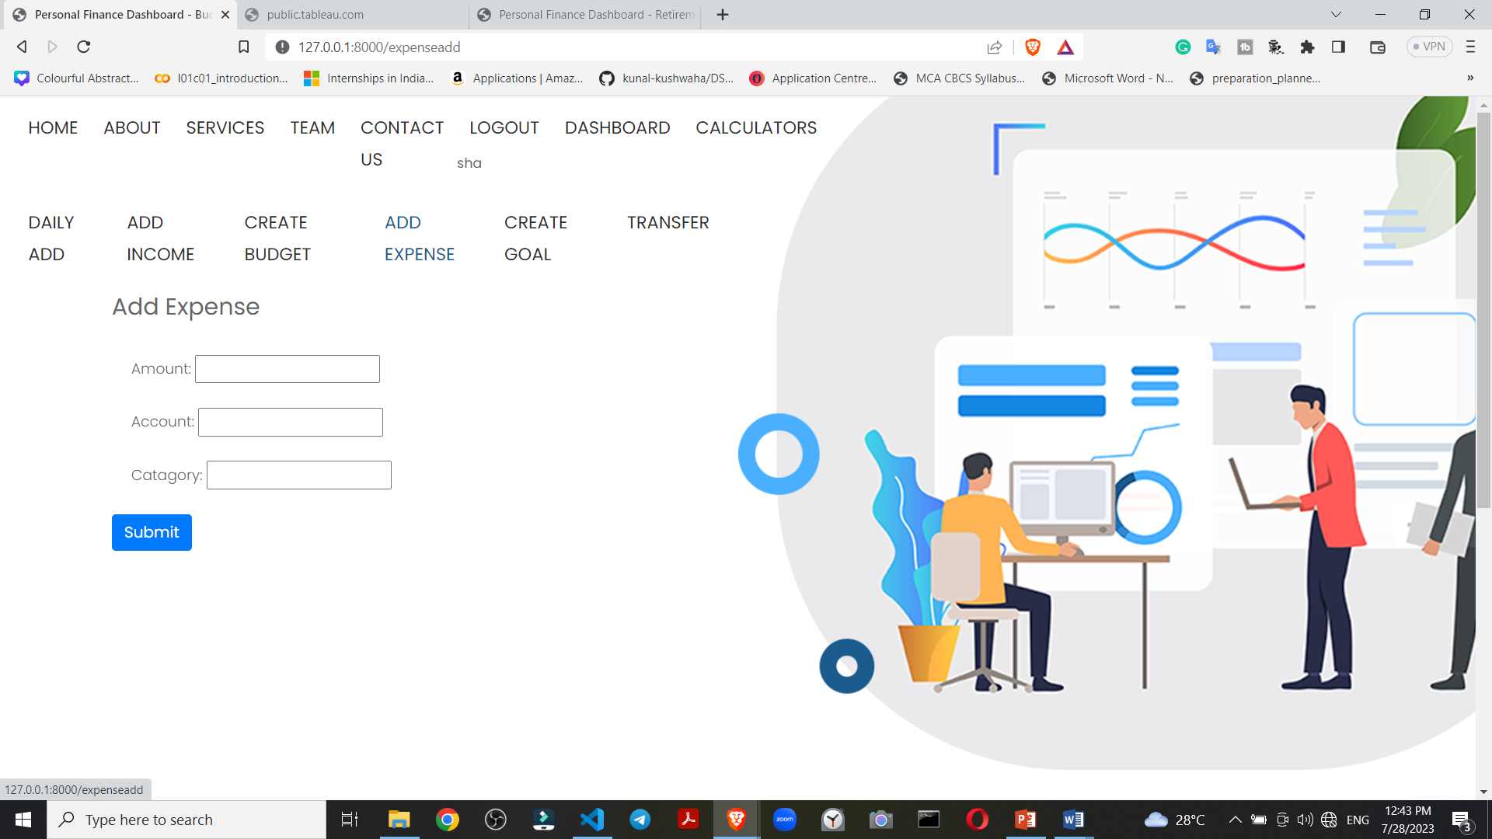

Figure 34 Add extra expense

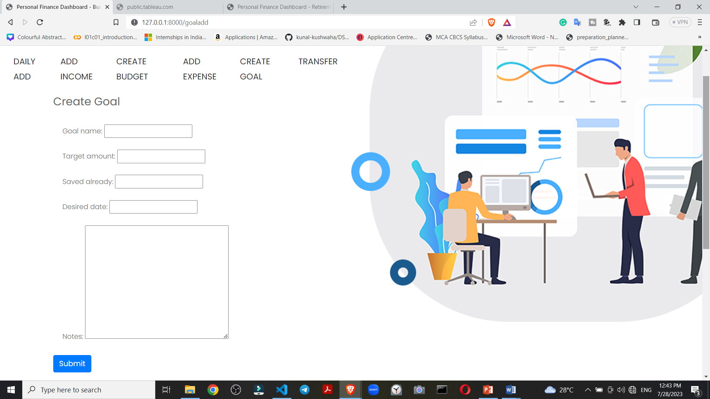

Figure 35 Create Goal for future financial

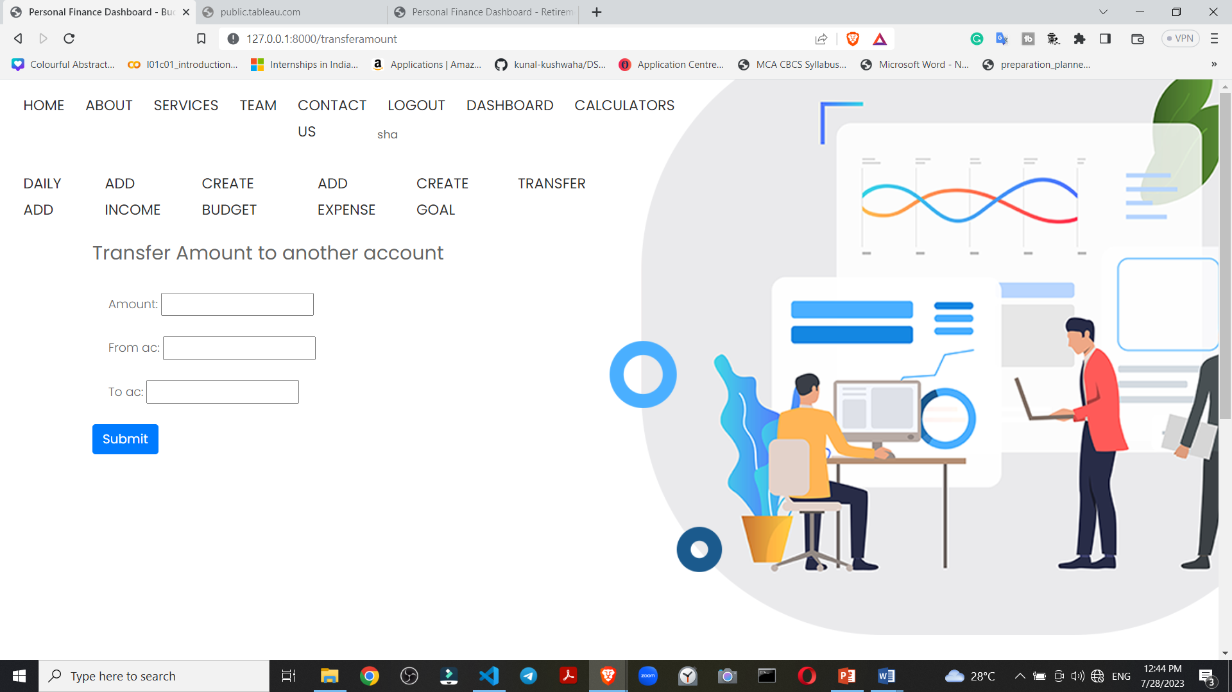

Figure 36 Transfer amount

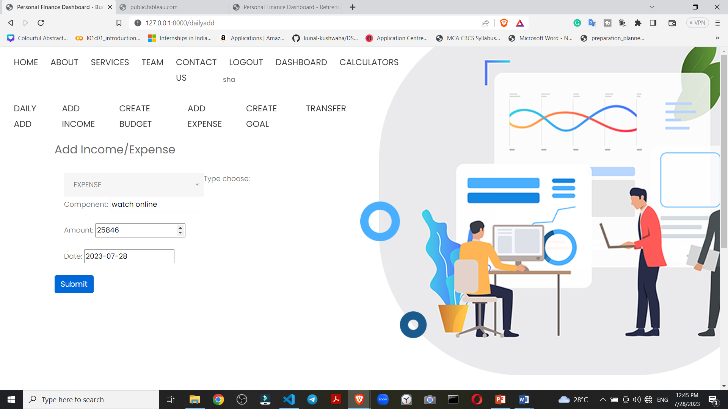

Figure 37 Extra income or expense add

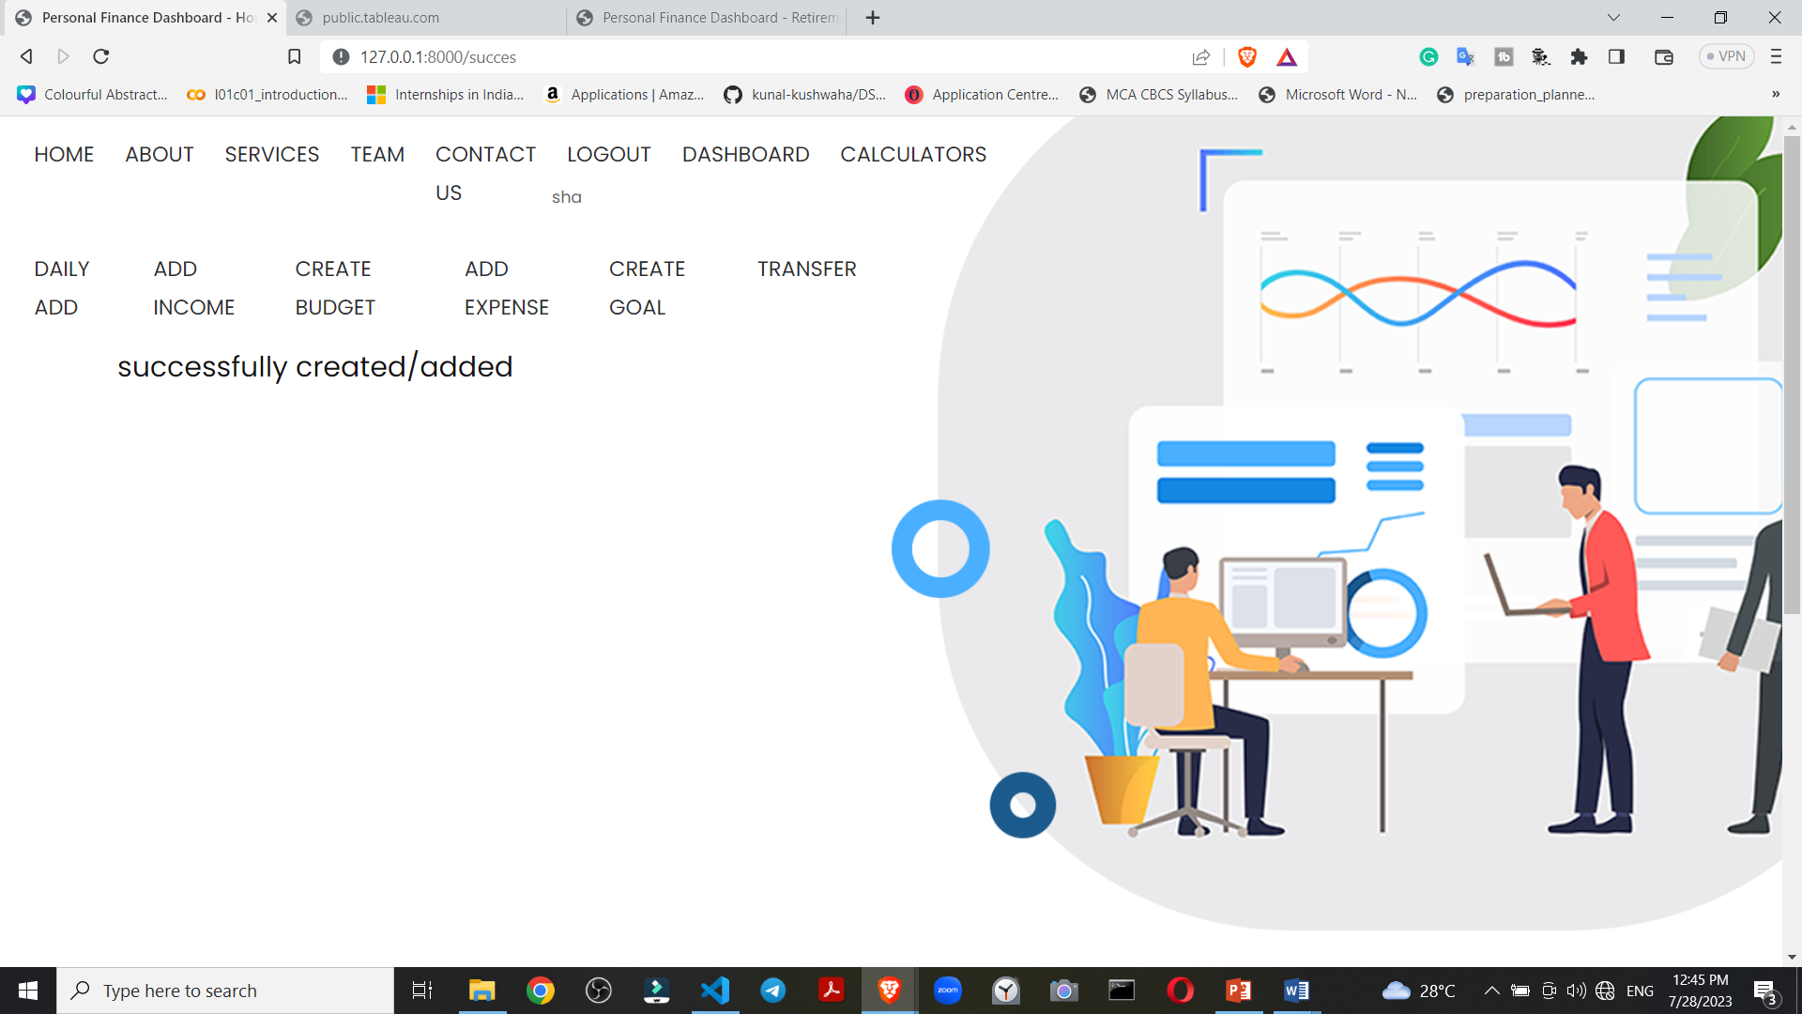

Figure 38 Successful added message page

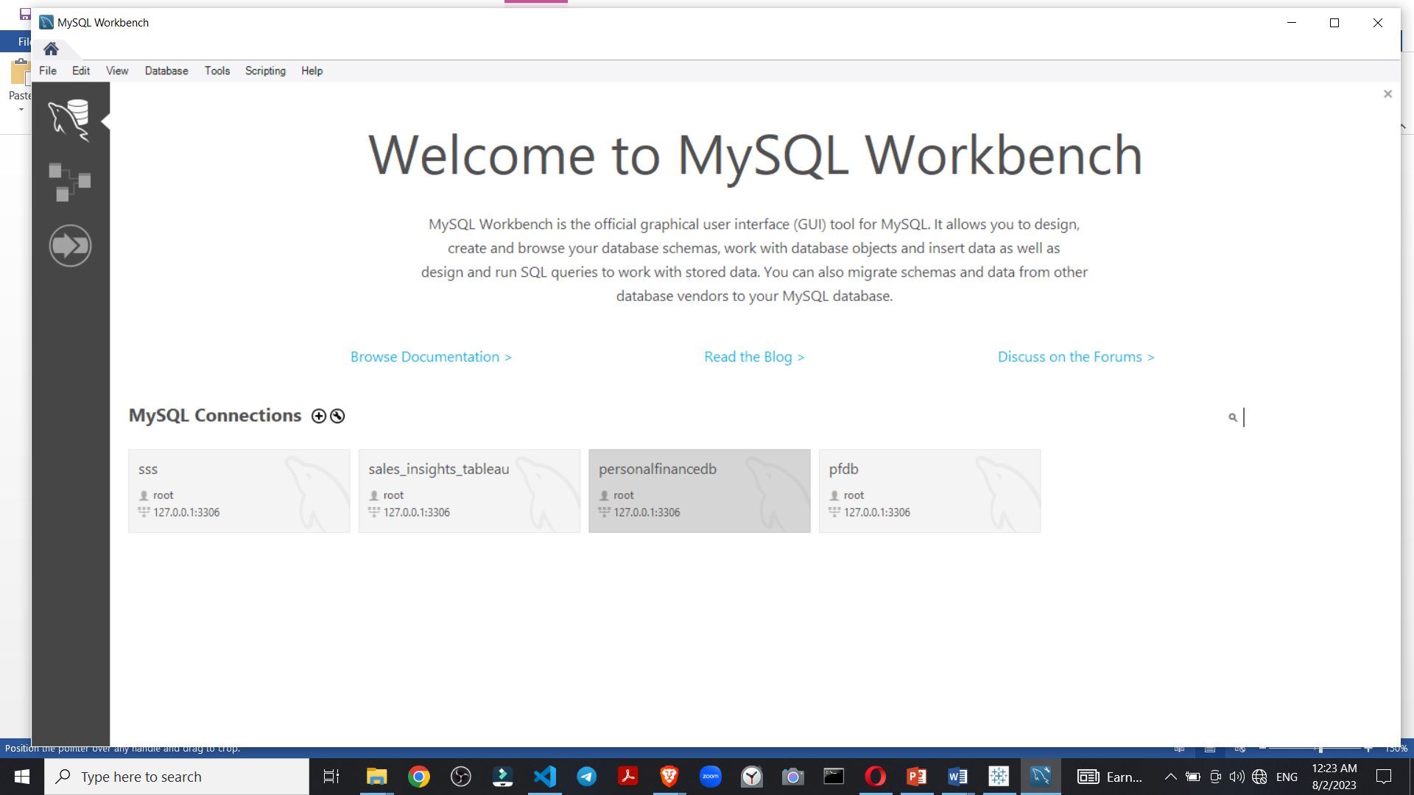

Figure 39 Connect local MySQL database

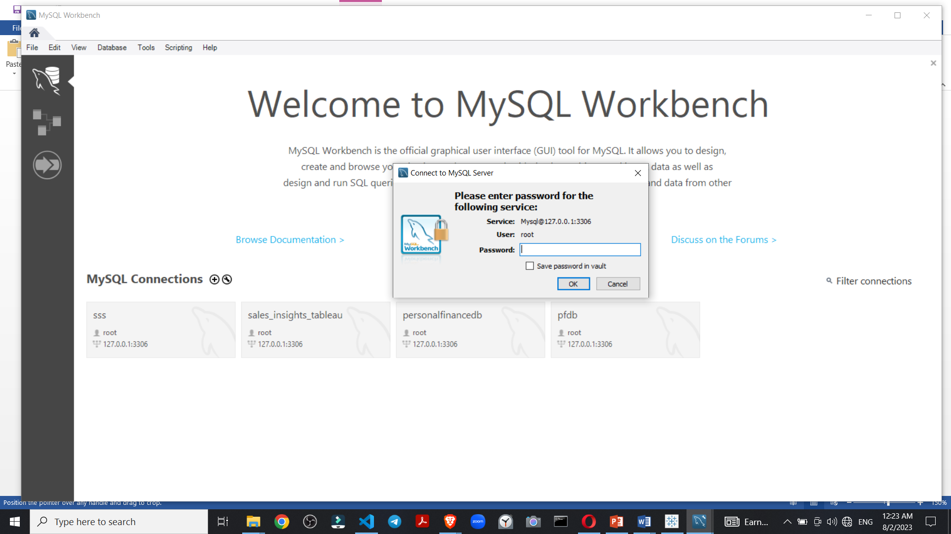

Figure 40 authentication

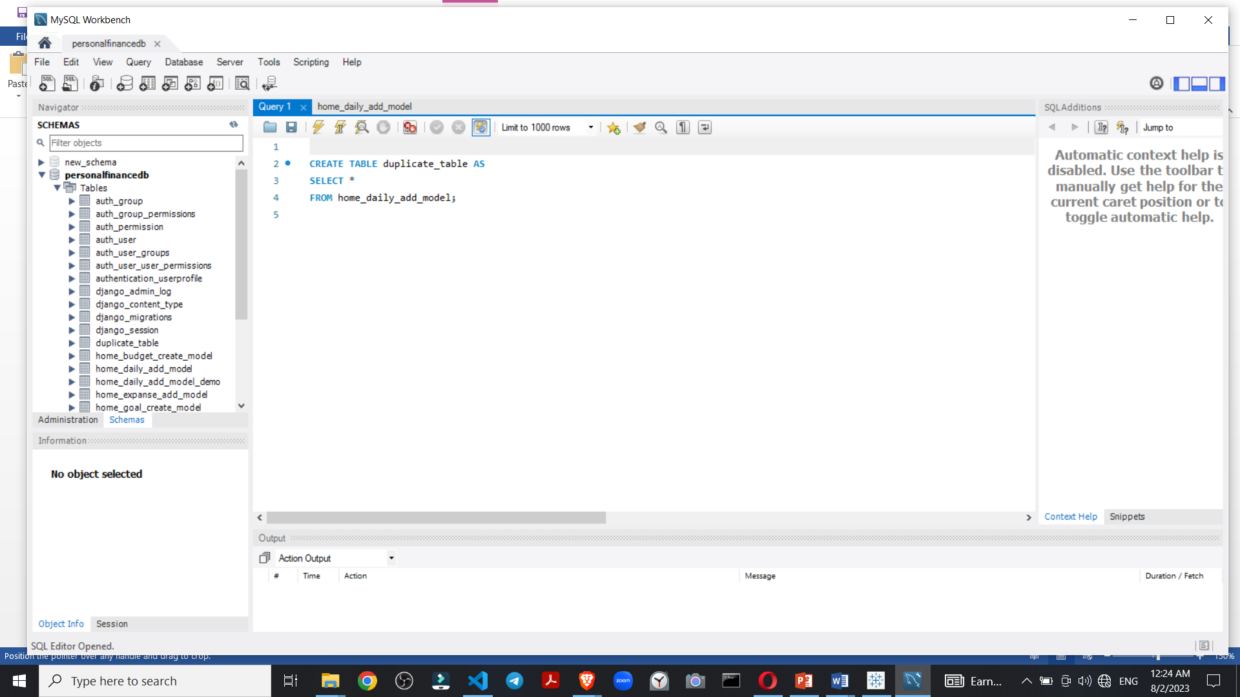Figure 41 Financial database schema

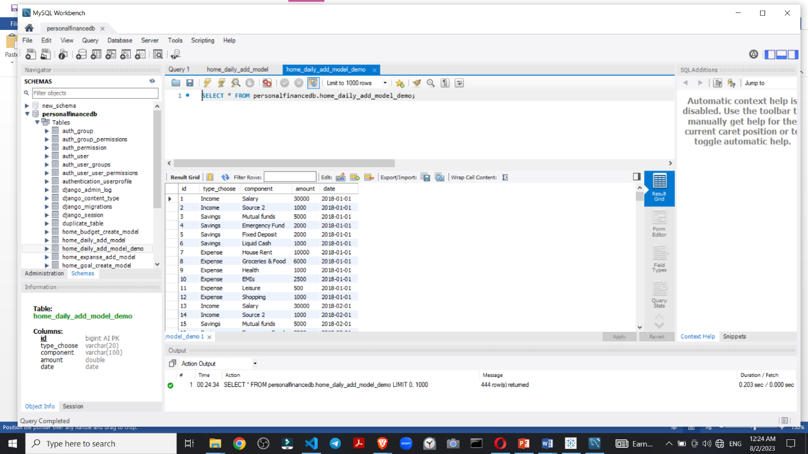

Figure 42 Run MySQL query

Sql query to show save data

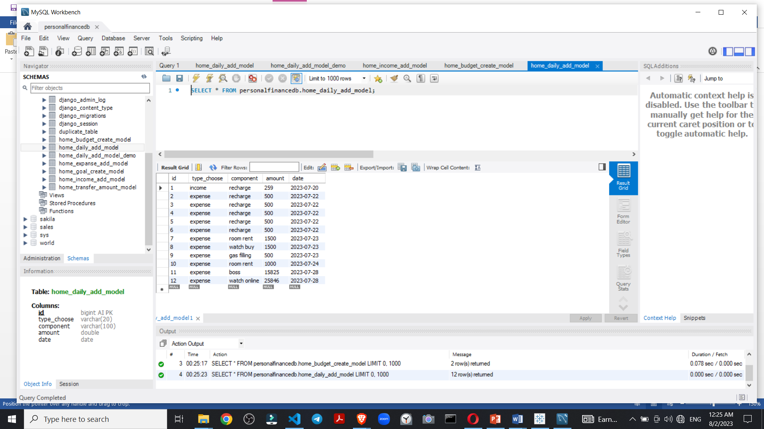

Figure 43 Show the latest data insert data into database

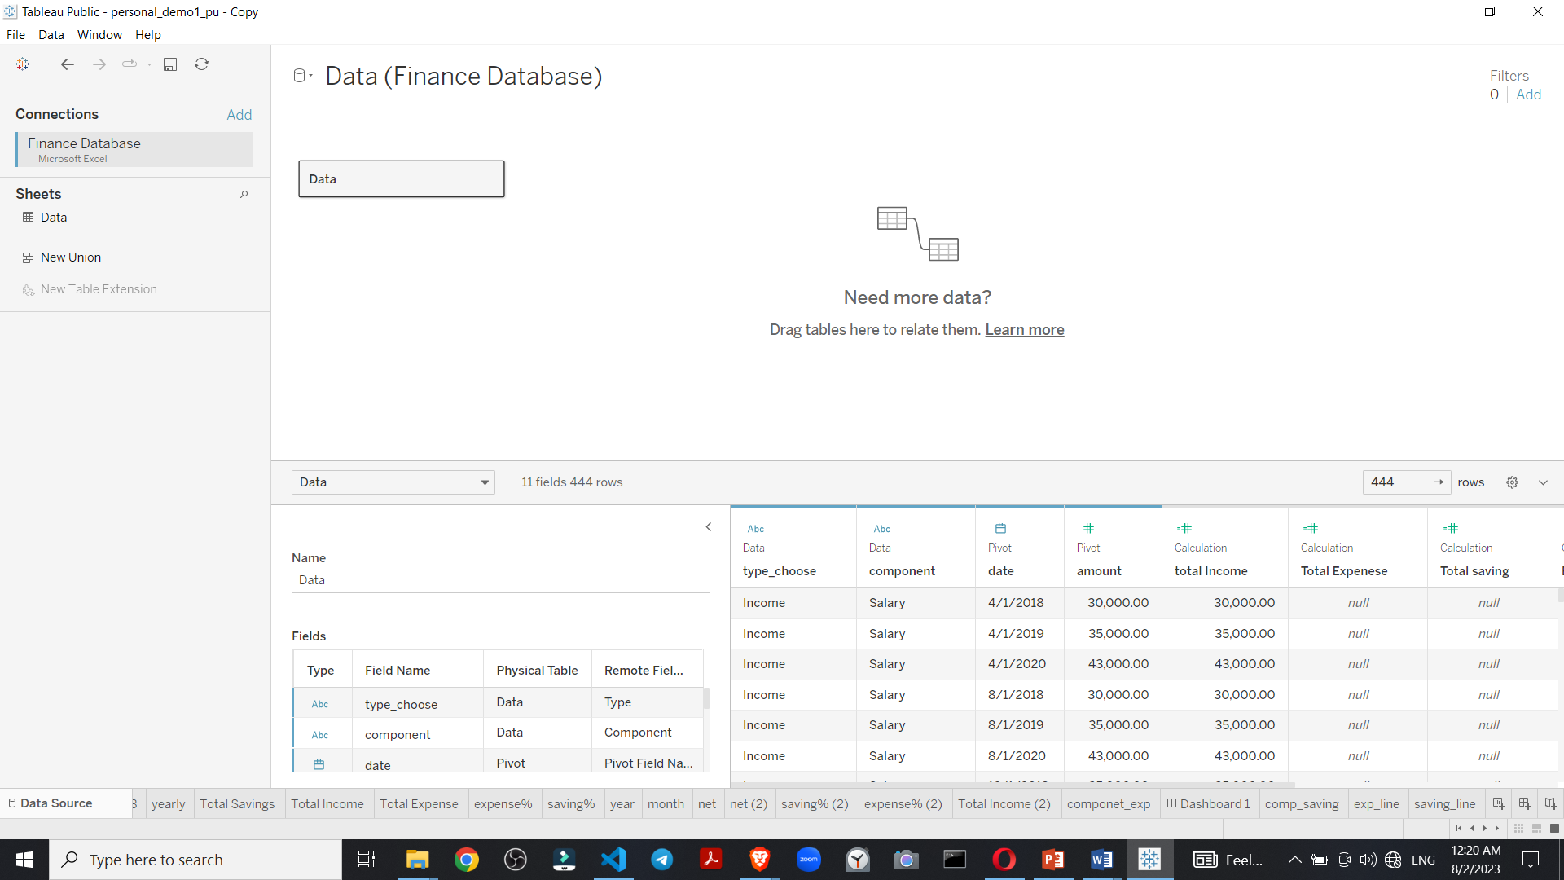

Figure 44 Dataset load in tableau

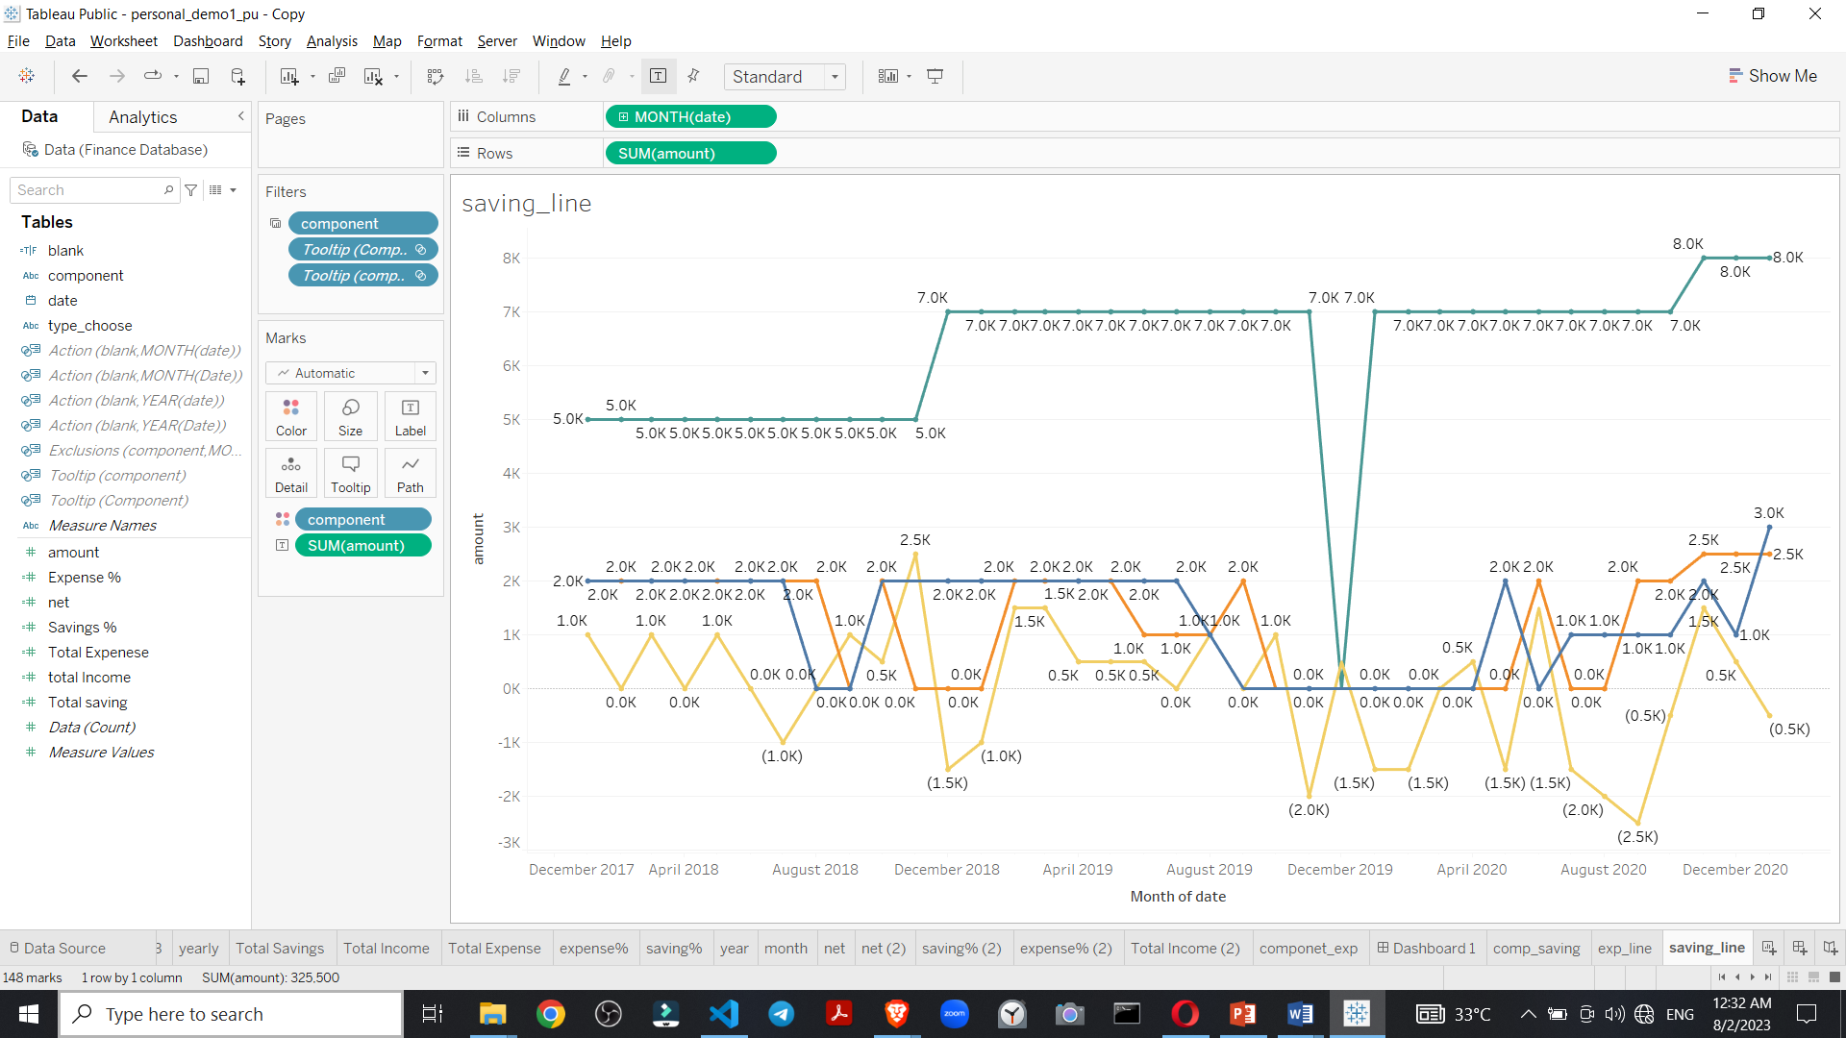

Figure 45 Tableau individual Worksheet create

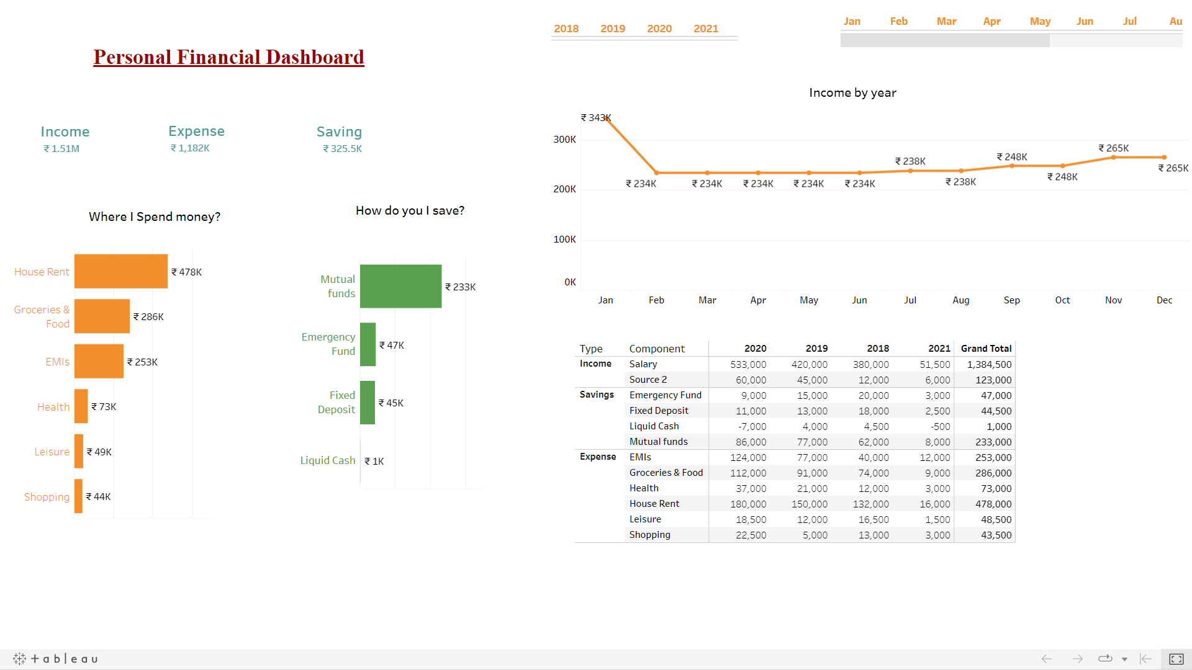

Figure 46 Personal financial management Dashboard

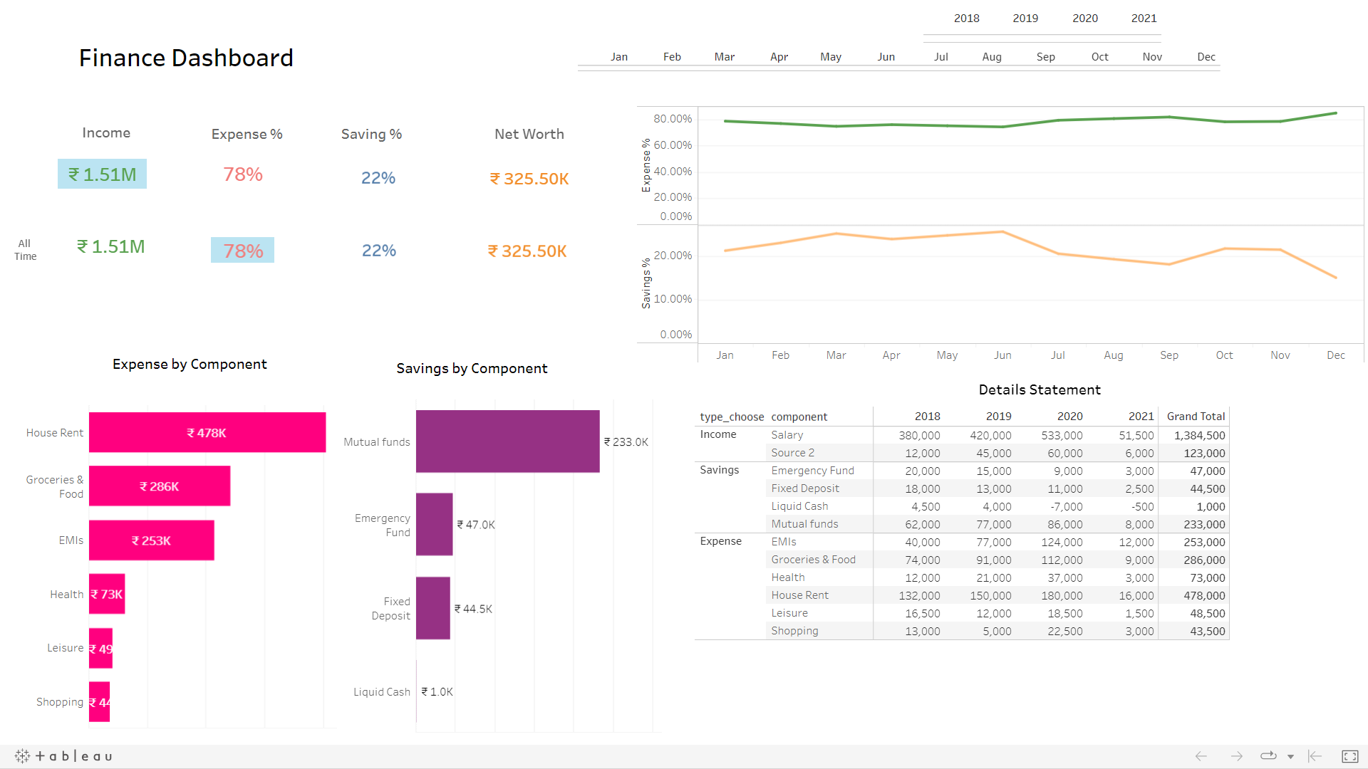

Figure 47 Details View Of your financial expense and net

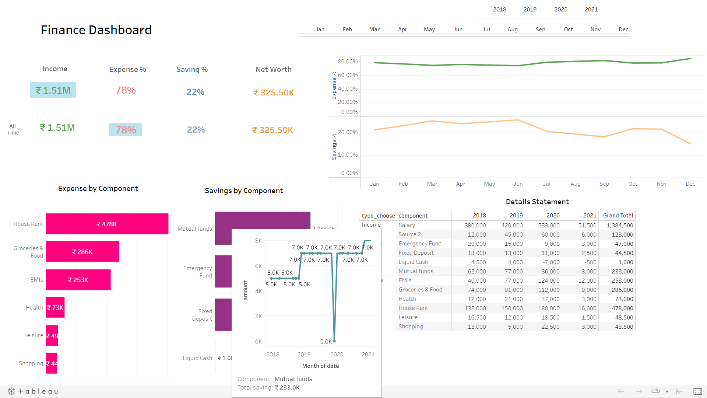

Figure 48 Show saving in line graph all time

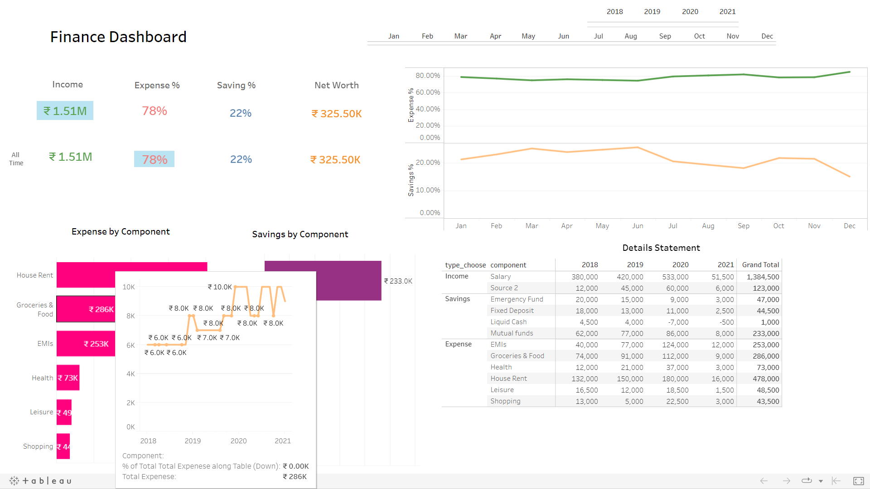

Figure 49 Histogram and line bar of expense

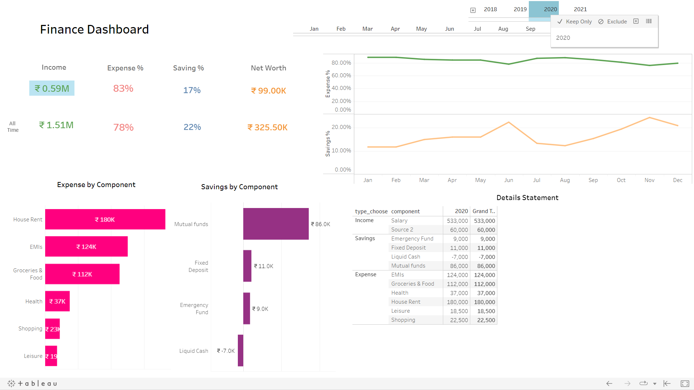

Figure 50 Yearly data graph of all

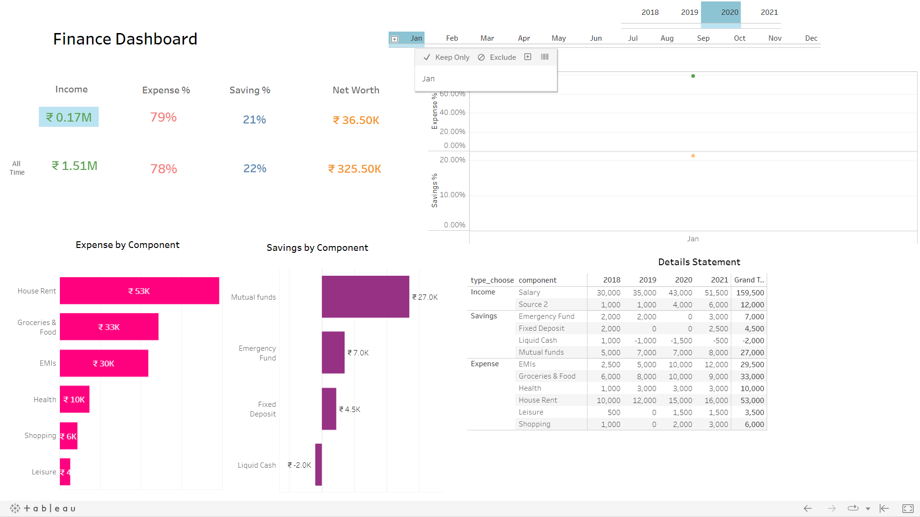

Figure 51 Monthly view of all

**Project Objectives and Scope:**

The primary objective of the project was to create a comprehensive platform that offers personalized financial analysis, insights, and actionable recommendations tailored to each user's unique financial goals and circumstances. The scope of the project encompassed financial data aggregation, budgeting, investment analysis, risk management, goal-based planning, and educational resources.

**Methodology and Approach:**

The project adopted an agile development methodology, allowing for iterative and incremental progress. The project team utilized Python as the primary programming language for backend and data analytics, Django as the web framework, and HTML/CSS/JavaScript for frontend development. The team collaborated closely to ensure effective communication and seamless integration of components.

**Achievement of Objectives:**

The project successfully achieved its primary objectives by delivering a robust and user-friendly platform. Users could create accounts, input their financial data, and access personalized financial analysis reports and recommendations. The platform's financial analysis algorithms provided accurate insights into users' financial health and helped them plan for the future effectively.

**User Experience and Feedback:**

User feedback played a crucial role in shaping the project's development. Early beta testing and user surveys allowed the team to identify areas for improvement. The project's user-centric approach led to a positive user experience, as users praised the platform's intuitive design and useful financial insights.

**Data Security and Privacy:**

Ensuring the security and privacy of users' financial data was a top priority. The project implemented industry-standard encryption and authentication measures to safeguard user information. Regular security audits and adherence to data protection regulations ensured users' confidence in the platform's security.

**Impact on Financial Literacy:**

The project's educational resources, including articles, tutorials, and interactive tools, received positive feedback from users. These resources effectively enhanced users' financial literacy and improved their understanding of personal finance concepts. Users reported feeling more confident in making financial decisions.

**Challenges Faced:**

The project faced challenges related to data aggregation from external financial sources and ensuring seamless integration with various financial institutions. Overcoming these challenges required collaborative efforts and technical expertise. Additionally, the team encountered scalability challenges during peak usage periods, requiring optimization strategies.

**Future Enhancements:**

Future enhancements for the project include expanding the platform's offerings to cover additional financial services such as estate planning and tax optimization. The project team plans to introduce a mobile app to provide users with convenient access to their financial data on-the-go.

**Project's Contribution and Significance:**

The project's contribution to the domain of personal financial management is significant. By empowering users with personalized financial analysis and recommendations, the platform helps users achieve their financial goals and build long-term financial security. The project aligns with the growing demand for digital financial services and the increasing focus on financial literacy.

**Lessons Learned:**

The project provided valuable lessons in agile development, user-centric design, and data security. The team learned the importance of continuous user feedback and iterative development to create a successful and impactful financial platform.

In conclusion, the Personal Financial Analysis and Recommendation project successfully achieved its objectives by delivering a user-centric and secure platform for financial management. The project's emphasis on financial literacy and personalized recommendations has positively impacted users' financial well-being. As the project continues to evolve, it is expected to have a broader impact on financial planning and decision-making for individuals.

**7. Its relevance & implication in company**

This project holds significant relevance and implications for Coursera as a company, aligning with its mission and strategic objectives. Let's explore the relevance and implications in detail:

**Relevance to Coursera:**

1. Strengthening Course Offerings: The project adds value to Coursera's Professional Data Analytics course by incorporating a real-world application that resonates with learners. By integrating personal financial analysis, learners can see the practical relevance of data analytics in their daily lives, making the course more engaging and applicable.

2. Addressing Learner Needs: Personal finance is a topic of universal interest and importance. By offering a project that helps learners analyze and manage their finances, Coursera addresses a significant need among its user base. This relevance boosts learner satisfaction and encourages more individuals to enroll in the course.

3. Showcasing Data Analytics Application: The project serves as an excellent showcase of data analytics application beyond traditional business use cases. Learners gain insights into how data analytics can be leveraged to improve personal financial decisions, fostering a deeper understanding of data analytics' versatility.

**Implications for Coursera:**

1. Enhanced Learner Engagement: The Personal Financial Analysis and Recommendation project enhances learner engagement and retention within the Professional Data Analytics course. Learners are more likely to stay motivated throughout the course as they see the direct impact of data analytics on their financial well-being.

2. Positive Brand Perception: By offering a project that has a tangible impact on learners' lives, Coursera enhances its brand perception as an educational platform that provides practical and relevant learning experiences. This positive perception can lead to increased customer loyalty and word-of-mouth referrals.

3. Market Differentiation: Integrating personal financial analysis in the Professional Data Analytics course sets Coursera apart from other online learning platforms. It positions Coursera as an innovative and forward-thinking provider that addresses learners' real-world needs.

4. Industry Recognition: The project's success in empowering learners to analyze and improve their personal finances can attract industry recognition and media coverage. This positive publicity can further elevate Coursera's reputation as a leading edtech company.

5. Data Analytics Expertise: Through the project, Coursera demonstrates its expertise in data analytics by creating a sophisticated platform that analyzes financial data effectively. This expertise can attract partnerships and collaborations with industry players seeking data analytics solutions.

In summary, the Personal Financial Analysis and Recommendation project holds considerable relevance and implications for Coursera. By incorporating personal finance into its data analytics course, Coursera enhances learner engagement, addresses a critical need, and reinforces its position as a leader in the edtech industry. The project showcases the practical application of data analytics and strengthens Coursera's brand as an innovative and user-centric learning platform. Ultimately, the project's success contributes to Coursera's mission of providing universal access to world-class education that empowers individuals to transform their lives.

**8. FINDINGS**

The findings of the Personal Financial Analysis and Recommendation project reveal valuable insights and outcomes from the implementation of the platform. These findings shed light on the effectiveness and impact of the project on learners and their financial well-being. Here are some key findings:

**1. Improved Financial Awareness**: Learners who participated in the project demonstrated a significant improvement in their financial awareness and understanding. By analyzing their personal finances through data analytics, learners gained insights into their spending patterns, savings, and investment behaviors.

**2. Enhanced Financial Planning:** The personalized financial analysis and recommendations provided by the platform empowered learners to develop more effective financial plans. Users reported that they could set realistic financial goals and create actionable strategies to achieve them.

**3. Increased Financial Confidence:** Learners expressed an increase in their financial confidence after using the platform. The project's educational resources played a vital role in enhancing users' financial literacy, enabling them to make informed financial decisions with more certainty.

**4. Positive Impact on Long-term Goals:** Users reported that the platform's goal-based planning feature helped them align their financial decisions with their long-term goals, such as retirement planning, buying a home, or funding their children's education.

**5. Greater Control over Finances:** Learners felt a sense of control over their finances, as they could track their financial progress and identify areas for improvement. This control led to a reduced level of financial stress and anxiety.

**6. Increased Adoption of Data Analytics Skills:** Through the project, learners gained hands-on experience in data analytics techniques. Many learners expressed an interest in applying their data analytics skills to other areas of their lives and careers.

**7. Recognition of Coursera's Value Proposition:** The integration of personal financial analysis in the Professional Data Analytics course added value to Coursera's course offerings. Learners appreciated the practicality and relevancy of the project and its direct impact on their financial well-being.

**8. Data Security Trust:** Users expressed confidence in the platform's data security measures, leading to a higher level of trust in sharing their financial information on the platform.

**9. Potential for Scaling and Expansion:** The success of the project suggests the potential for scaling the platform to cater to a broader audience. Learners expressed interest in accessing the platform on mobile devices and integrating additional financial services.

In conclusion, the findings of the Personal Financial Analysis and Recommendation project demonstrate its effectiveness in improving learners' financial awareness, planning, and confidence. The project's positive impact on users' long-term financial goals and data analytics skills highlights its significance as a transformative learning experience. Coursera's commitment to providing practical and relevant educational resources has been validated through the positive feedback and recognition received from learners. The project's success opens opportunities for scaling and expanding the platform, reinforcing Coursera's position as a leader in the edtech industry.

**9. CONCLUSION**

In conclusion, the Personal Financial Analysis and Recommendation project, undertaken as part of Coursera's Professional Data Analytics course, has proven to be a transformative learning experience with significant implications for both learners and the company.

The project successfully achieved its objectives by empowering learners with personalized financial analysis, insights, and recommendations. Through the platform, learners improved their financial awareness, gained greater control over their finances, and developed effective financial planning strategies aligned with their long-term goals. The project's positive impact on learners' financial confidence and data analytics skills demonstrates its relevance and effectiveness in addressing real-world challenges.

Coursera's commitment to providing accessible and high-quality education is further strengthened through the project. By incorporating personal finance into the data analytics course, Coursera demonstrates its responsiveness to learners' needs and the platform's potential to add value beyond traditional academic subjects.

The project's positive impact on learners' financial well-being contributes to Coursera's mission of providing universal access to world-class education. By equipping individuals with essential financial skills, the project empowers learners to make informed financial decisions, improve their financial security, and enhance their overall financial literacy.

The success of the Personal Financial Analysis and Recommendation project highlights Coursera's expertise in data analytics and its commitment to continuous improvement. The project's positive reception from learners further solidifies Coursera's position as a trusted edtech company and enhances its brand reputation in the industry.

Looking ahead, the project's findings and achievements offer valuable insights for future course development and platform enhancements. The potential for scaling and expanding the platform to cater to a broader audience opens new opportunities for Coursera to make a lasting impact on learners worldwide.

In summary, the Personal Financial Analysis and Recommendation project exemplifies Coursera's commitment to innovation, learner-centric education, and social impact. It showcases the power of data analytics in transforming individuals' financial well-being and reinforces the project's significance in the field of personal finance education. With its positive outcomes and potential for growth, the project represents a milestone in Coursera's journey of providing accessible and impactful education to learners around the globe.

**10. FURTHER ENHANCEMENT (Suggestion)**

For further enhancement, the Personal Financial Analysis and Recommendation project can consider incorporating the following suggestions:

**Advanced Data Visualization:** Enhance the platform's data visualization capabilities to provide users with more interactive and insightful visual representations of their financial data. Implementing advanced charts, graphs, and infographics can help users better understand their financial trends and patterns.

**Customizable Financial Goals:** Allow users to set and customize their financial goals based on their unique circumstances. Offering a range of pre-defined financial goals and the option to create custom goals will make the platform more personalized and relevant to individual users.

**Machine Learning for Predictive Analysis:** Integrate machine learning algorithms to offer predictive financial analysis, such as predicting future income, expenses, and investment returns. This will enable users to make proactive financial decisions and plan for various scenarios.

**Gamification and Rewards:** Implement gamification elements to engage and motivate users in managing their finances. Introducing a reward system for achieving financial milestones or completing educational modules can incentivize users to stay committed to their financial goals.

**Real-time Data Updates:** Enable real-time data synchronization with users' financial accounts to provide up-to-date information on their financial status. This feature will ensure that users always have the most current financial insights.

**Social Sharing and Collaboration:** Introduce social sharing features that allow users to share their financial progress and achievements with their networks. Additionally, consider incorporating collaborative financial planning features for families or couples who wish to manage their finances together.

**AI-driven Financial Recommendations:** Leverage artificial intelligence (AI) to offer more personalized and data-driven financial recommendations. AI algorithms can analyze users' financial data in real-time and provide tailored suggestions for budgeting, investment strategies, and debt management.

**Expanded Educational Resources:** Expand the collection of educational resources to cover a broader range of financial topics, including tax planning, retirement strategies, estate planning, and risk management. These resources can be delivered through articles, webinars, or expert-led courses.

**Integration of Financial Calculators:** Integrate interactive financial calculators, such as retirement calculators, loan calculators, and investment calculators, to assist users in making informed financial decisions.

**User Feedback and Surveys:** Continuously gather user feedback through surveys and assessments to identify areas for improvement and understand user preferences. Regularly incorporating user feedback will ensure that the platform stays relevant and meets users' evolving needs.

By implementing these suggestions, the Personal Financial Analysis and Recommendation project can further elevate its impact on learners' financial well-being and enhance Coursera's position as a leader in providing practical and transformative educational experiences. The project's continuous improvement and commitment to meeting users' financial goals will contribute to its long-term success and positive influence on financial literacy worldwide.

**11. BIBLIOGRAPHY**

# 1. Cataldo Musto (2015) Case-based Recommender Systems for Personalized Finance Advisory <https://www.slideshare.net/Cataldo/casebased-recommender-systems-for-personalized-finance-advisory>

2. Giovanni Semeraroa, Pasquale Lopsa, Marco de Gemmisa (2017) <http://bit.ly/3KpqnMG>

3. Young-Woo Seo, Joseph A. Giampapa, and Katia P. Sycara Carnegie Mellon University <https://www.cs.cmu.edu/~youngwoo/doc/financial_news_analysis.pdf>

4. Robert P. Schumaker and Hsinchun Chen (2015) The University of Arizona <https://bit.ly/44Q1a6x>

5. AI Bot (2023) <https://chat.openai.com/c/87cc0baf-f6c9-4b7c-b82c-98b4960acf45>

**12. REFERENCE WEBSITE**

<https://github.com/shahil04/personal_finance_webapp.git>

<https://kristian-roopnarine.medium.com/creating-a-budget-web-app-with-django-655369b6d43c>

<https://github.com/Kristian-Roopnarine/Django-Budget-App/blob/master/budget_project/budget_app/models.py>

<https://www.emizentech.com/blog/how-to-develop-a-personal-finance-management-app.html>

<https://kb.tableau.com/articles/howto/calculating-percent-of-total-for-measure-values>

<https://www.educba.com/tableau-if-statement/>

<https://sarahlovesdata.co.uk/2019/01/15/how-to-create-tooltip-headers-using-viz-in-tooltips-in-tableau>

<https://www.tableau.com/products/mobile> //tableau mobile

<https://github.com/tableau/mobile-app-bootstrap-cordova>

<https://github.com/tableau>

<https://github.com/Gaelim/Populatiry-Engine>

<https://github.com/codebasics/DataAnalysisProjects>

<https://codebasics.io/resources/end-to-end-data-analyst-project>

<https://docs.appseed.us/products/django-dashboards/atlantis-dark>

<https://www.emizentech.com/blog/how-to-develop-a-personal-finance-management-app.html>